CHAPTER 1
INTRODUCTION
The integration of Artificial Intelligence (AI) into the healthcare sector has opened new possibilities for improving accessibility, efficiency, and quality of medical services[1]. In recent years, there has been a growing demand for digital healthcare solutions that can provide immediate assistance to users, especially for preliminary symptom analysis[2]. Traditional healthcare systems often face challenges such as limited availability of medical professionals, long waiting times, and dependence on manual diagnosis, which can delay timely medical attention[3].
At the same time, the increasing use of online platforms for self-diagnosis has led to widespread issues related to misinformation and unsafe medical practices[4]. Many users rely on unverified sources or generic AI chatbots, which may provide inaccurate guidance or suggest inappropriate medications without considering medical safety[5]. Such systems often lack structured reasoning, confidence evaluation, and proper escalation mechanisms, making them unreliable for healthcare use[6].
To address these challenges, this project proposes an AI-Driven Healthcare Decision Support System that goes beyond a simple chatbot by incorporating multiple layers of intelligence and safety[7]. The system is designed to interact with users through a conversational interface, collect symptom-related information in a structured manner, and analyze it using a combination of medical knowledge, rule-based logic, and AI techniques[8]. Unlike conventional systems, it ensures that responses are grounded in verified medical data through a Retrieval-Augmented Generation (RAG) approach, thereby reducing the risk of incorrect or misleading information[9].
A key aspect of the proposed system is its strong focus on safety and reliability. It includes a dedicated Medication Safety Engine that restricts recommendations to safe over-the-counter (OTC) medications and prevents the suggestion of prescription or harmful drugs. Additionally, the system incorporates a risk classification mechanism that categorizes cases into different severity levels and ensures that high-risk or uncertain situations are automatically escalated to qualified healthcare professionals.
The system is also designed to be modular and scalable, allowing future integration with advanced technologies such as wearable devices, electronic health records, and telemedicine platforms. By combining AI-driven analysis with strict safety protocols and human intervention mechanisms, the proposed solution aims to provide a balanced approach that enhances digital healthcare while maintaining clinical responsibility.
1.1 Need Identification
In the modern digital era, access to healthcare information has become easier than ever before. However, the availability of information does not necessarily guarantee its accuracy, reliability, or safety[4]. A large number of individuals rely on internet searches, social media platforms, and generic AI-based chatbots to understand their symptoms and health conditions. While these platforms provide quick responses, they often lack medical validation, leading to misinformation, incorrect self-diagnosis, and unsafe medication practices[6].
One of the major challenges in the healthcare sector is the limited accessibility to immediate medical guidance, especially for individuals in rural or remote areas[3]. Patients often face delays in consulting doctors due to long waiting times, high consultation costs, or lack of nearby healthcare facilities[2]. As a result, people tend to ignore early symptoms or rely on unreliable sources, which can worsen their condition over time.
Another critical issue is the overburdening of healthcare systems, where medical professionals are required to handle both critical and non-critical cases[1]. Many patients visit doctors for minor conditions that could be managed with basic guidance, increasing the workload on healthcare providers and reducing their availability for more serious cases. This creates a need for an intelligent system that can handle preliminary health assessments and reduce unnecessary hospital visits.
Furthermore, existing AI-based healthcare tools often lack safety mechanisms and structured decision-making. These systems may provide generalized responses without considering factors such as symptom severity, duration, or associated conditions. In some cases, they may even suggest prescription drugs or potentially harmful treatments without proper medical supervision. This highlights the urgent need for a system that prioritizes patient safety and adheres to medical guidelines.
There is also a significant requirement for a system that can convert unstructured user input into structured medical data, enabling more accurate analysis and decision-making. Without structured data, it becomes difficult to assess the reliability of the system’s output or to provide context-aware recommendations.
To address these challenges, there is a clear need for a Healthcare Decision Support System that combines Artificial Intelligence with strict safety protocols and medical knowledge. Such a system should:
- Provide accurate and context-aware symptom analysis
- Ensure that recommendations are based on verified medical knowledge
- Restrict unsafe or prescription medication suggestions
- Classify cases based on risk levels
- Automatically escalate high-risk situations to qualified healthcare professionals
- Offer a user-friendly interface for seamless interaction
The proposed system fulfills these requirements by integrating conversational AI, a medical knowledge base, a medication safety engine, and a doctor intervention mechanism. By doing so, it aims to provide a reliable, safe, and accessible healthcare solution that bridges the gap between digital convenience and clinical responsibility.

1.2 Identification of Problem
Despite the rapid growth of digital healthcare solutions and AI-based applications, several critical issues still exist that limit their effectiveness, reliability, and safety. While many platforms attempt to provide instant medical guidance, they often fail to meet the standards required for real-world healthcare applications[11]. The following problems have been identified as key challenges in existing systems:

1.2.1 Lack of Accurate and Reliable Medical Guidance
Most online healthcare platforms and AI chatbots provide generalized responses that are not tailored to individual users[12]. These systems often lack access to structured and verified medical knowledge, resulting in inaccurate or incomplete guidance. As a result, users may receive misleading information that does not correctly reflect their condition.

1.2.2 Risk of Unsafe Medication Recommendations
One of the most serious issues in existing AI healthcare tools is the potential to suggest inappropriate or harmful medications. Many systems do not differentiate between over-the-counter (OTC) and prescription drugs, which can lead to unsafe recommendations. This can pose significant health risks, especially when users follow such advice without consulting a doctor[13].

1.2.3 Absence of Risk-Based Classification
Current systems often fail to classify health conditions based on severity. They treat all inputs similarly, without distinguishing between mild symptoms and potentially life-threatening conditions. This lack of risk assessment can result in critical cases being overlooked, delaying necessary medical intervention[14].

1.2.4 Lack of Confidence Evaluation Mechanism
Most AI-based healthcare systems do not provide any measure of confidence or reliability for their outputs[15]. Without a confidence evaluation mechanism, users cannot determine whether the suggested guidance is trustworthy, increasing the risk of incorrect decision-making.

1.2.5 No Human-in-the-Loop Integration
Existing systems are largely automated and do not involve healthcare professionals when required. There is no proper mechanism to escalate high-risk or uncertain cases to qualified doctors[16]. This complete reliance on AI reduces the safety and effectiveness of such systems.

1.2.6 Unstructured Symptom Analysis
Users typically provide symptoms in free-text format, and many systems fail to convert this input into structured medical data. Without structured analysis, it becomes difficult to perform accurate diagnosis or apply meaningful reasoning, leading to poor system performance[17].

1.2.7 Lack of Integrated Healthcare Services
Most platforms operate as standalone tools and do not provide additional services such as doctor consultation or appointment booking[18]. This creates a gap between symptom analysis and actual medical care, reducing the practical usefulness of the system.
1.2.8 Lack of Context Awareness
Many existing systems fail to consider important contextual factors such as age, medical history, lifestyle, or duration of symptoms. Without contextual understanding, the system may provide generic responses that are not suitable for individual users, reducing the accuracy and usefulness of the recommendations[19].
1.2.9 Over-Reliance on AI Without Validation
Several AI-based healthcare tools rely entirely on machine learning models without incorporating rule-based validation or medical safeguards[20]. This can result in AI hallucinations, where the system generates incorrect or misleading information that appears convincing but is medically inaccurate.
1.2.10 Absence of Explainability
Most systems do not explain how a particular recommendation or conclusion was reached. The lack of transparency reduces user trust and makes it difficult to verify whether the system’s output is logically and medically sound[21].
1.2.11 Inability to Handle Ambiguous Inputs
Users often describe symptoms in vague or incomplete ways. Existing systems struggle to handle such ambiguity and fail to ask follow-up questions, leading to incomplete analysis and unreliable results[22].
1.2.12 No Adaptive Questioning Mechanism
Traditional systems do not follow an interactive questioning approach similar to a doctor[23]. They fail to dynamically adjust questions based on user responses, which limits their ability to gather detailed and accurate medical information.

1.3 Identification of Tasks
To develop a robust and reliable AI-Driven Healthcare Decision Support System, the entire project is divided into multiple well-defined tasks. Each task focuses on a specific functional or technical component of the system[24]. This modular approach ensures better organization, easier debugging, scalability, and efficient integration of different technologies.
The tasks are designed to cover all aspects of system development, including user interaction, backend processing, artificial intelligence, safety validation, and deployment.

1.3.1 Frontend Development (User Interface)
The frontend is the user-facing layer of the system, responsible for enabling smooth interaction between the user and the healthcare platform. Since the system deals with medical information, the interface must be intuitive, clear, and easy to use for individuals with varying levels of technical knowledge.
The frontend is developed using Streamlit, which allows rapid creation of interactive web applications with minimal complexity[26].
The detailed tasks involved include:
- Designing a chat-based conversational interface that allows users to describe their symptoms naturally
- Implementing a guided interview system, where the application asks follow-up questions dynamically based on user responses
- Displaying results in a structured format, including:
  - Possible condition insights
  - Risk level (mild, moderate, severe)
  - Safe medication suggestions (only OTC)
  - Precautionary advice
- Developing a doctor appointment booking interface, allowing users to select available doctors and time slots
- Managing user sessions to maintain conversation continuity
- Ensuring a responsive and clean layout for better readability and usability
This module ensures that the system is accessible, interactive, and user-friendly, which is critical for healthcare applications.

1.3.2 Backend Integration (FastAPI)
The backend acts as the core processing unit of the system, handling all business logic, data flow, and integration between different modules.
The backend is implemented using FastAPI, which is chosen for its high performance, asynchronous capabilities, and ease of integration with AI models[26].
The detailed tasks include:
- Designing and implementing RESTful APIs to handle communication between frontend and backend
- Managing user sessions and conversation flow, ensuring that multiple users can interact with the system independently
- Processing raw user input and converting it into structured symptom data
- Coordinating interactions between:
  - AI modules
  - Knowledge base
  - Safety engine
- Handling data storage for:
  - User interactions
  - Doctor appointments
- Ensuring system reliability, scalability, and efficient response times
- Implementing error handling and fallback mechanisms
The backend ensures that the system operates smoothly and efficiently while maintaining a modular architecture.

1.3.3 AI Integration
Artificial Intelligence is the core intelligence layer of the system, enabling it to analyze symptoms, retrieve relevant information, and generate meaningful responses.
The AI component is carefully designed to ensure accuracy, explainability, and safety[27].
The detailed tasks involved include:

a) Medical Knowledge Base Development
- Creating structured medical data containing:
  - Symptoms
  - Conditions
  - Safe OTC medications
  - Precautionary advice
- Ensuring that all data is verified and medically accurate

b) Retrieval-Augmented Generation (RAG)
- Implementing a system where:
  - User input is converted into embeddings
  - Relevant medical documents are retrieved using vector search (FAISS)
- Providing context to the AI model so that responses are based on verified knowledge rather than guesses

c) Risk Classification Engine
- Categorizing cases into:
  - Mild
  - Moderate
  - Severe
- Using rule-based logic to detect critical symptoms (e.g., chest pain, breathing difficulty)

d) Confidence Scoring Mechanism
- Assigning a confidence score to each prediction
- Ensuring:
  - High confidence → safe response
  - Low confidence → doctor escalation

e) Local LLM Integration
- Integrating a local language model (via Ollama)
- Generating responses that:
  - Are natural and conversational
  - Follow strict safety rules
- Avoiding dependency on external APIs for privacy and cost efficiency
This module ensures that the system is intelligent, context-aware, and reliable.

1.3.4 Safety and Validation Engine
This is the most critical module of the system, ensuring that all outputs are medically safe and responsible[28].
The detailed tasks include:
- Defining a list of allowed OTC medications
- Defining a list of blocked medications, including:
  - Sleeping pills
  - Antibiotics
  - Steroids
  - Strong painkillers
- Detecting high-risk symptoms such as:
  - Chest pain
  - Breathing difficulty
  - Unconsciousness
- Implementing rules to:
  - Block unsafe recommendations
  - Trigger doctor escalation
- Applying confidence thresholds to prevent unreliable outputs
This module acts as a safety firewall, ensuring that AI cannot produce harmful results.

1.3.5 Knowledge Base and Data Management
The knowledge base is responsible for storing and retrieving structured medical information[29.]

Tasks include:
- Organizing medical data into structured formats
- Implementing vector database (FAISS) for semantic search
- Converting medical documents into embeddings
- Enabling fast and accurate retrieval of relevant information
- Maintaining consistency and accuracy of medical data
This component ensures that the system is knowledge-driven rather than guess-based.

1.3.6 Doctor Interaction and Appointment Module
To ensure real-world usability, the system includes a module for connecting users with healthcare professionals[30].
Tasks include:
- Creating a doctor listing interface
- Allowing users to:
  - Select doctor
  - Choose available time slots
- Storing appointment data in structured format (JSON/database)
- Providing a smooth transition from AI guidance to human consultation
This ensures the system is not just informational but also actionable.

1.3.7 Deployment and System Integration
The final task involves combining all modules into a single working system and making it ready for deployment[31].

Tasks include:
- Integrating frontend, backend, and AI components
- Testing system functionality under different scenarios
- Running backend server using FastAPI
- Launching frontend using Streamlit
- Managing code using GitHub
- Preparing the system for future deployment on cloud platforms such as AWS

1.4 Project Timeline
The development of the proposed AI-Driven Healthcare Decision Support System follows a systematic and structured timeline to ensure efficient execution of all phases. The project is divided into multiple stages, each focusing on a specific aspect of system development, from problem identification to final deployment and documentation. This phased approach helps in maintaining clarity, tracking progress, and ensuring timely completion of the project.

Week | Phase | Activities
1 | Ideation & Planning | Define project objectives, identify healthcare problems, research AI healthcare systems, finalize tech stack
2 | System Design | Design system architecture, define modules (AI, backend, frontend, safety engine), plan data flow
3 | Knowledge Base Development | Create medical dataset, define symptoms & conditions, prepare OTC medication data
4 | Backend Development | Develop APIs using FastAPI, implement symptom processing, integrate core system modules
5 | AI Integration | Implement vector database (FAISS), develop RAG system, integrate local LLM (Ollama)
6 | Safety Engine & Risk Model | Implement medication safety rules, risk classification (mild/moderate/severe), confidence scoring
7 | Frontend Development | Build Streamlit interface, implement chat UI, develop symptom interview flow, display results
8 | Integration & Testing | Integrate frontend, backend, and AI modules, test system behavior, debug errors
9 | Doctor Module & Enhancement | Implement doctor appointment system, store data, improve user interaction
10 | Deployment & Finalization | Run system locally, version control with GitHub, prepare documentation and report

Table 1: Project Timeline by Week

Each phase of the timeline was carefully calibrated to balance thoroughness with agility. The early weeks invested heavily in planning and design activities, recognizing that decisions made at this stage have disproportionate impact on subsequent development work. The middle weeks focused on the core technical implementation, with testing activities interwoven throughout rather than deferred to a single validation phase. The final weeks prioritized launch readiness and operational monitoring, ensuring a smooth transition from development to production.

1.5 Organization of the Report
The project report is organized in a structured manner to present the development and implementation of the proposed AI-Driven Healthcare Decision Support System in a clear and systematic way. Each chapter focuses on a specific aspect of the project, ensuring logical flow and easy understanding.
• Chapter 1 — Introduction: Presents an overview of the project, including need identification, problem statement, identification of tasks, and project timeline. It establishes the foundation and objectives of the system.

• Chapter 2 — Background Study: Covers the study of existing healthcare systems, AI-based solutions, and related technologies. It includes analysis of current limitations, comparison of approaches, and a summary of findings that justify the proposed solution.
• Chapter 3 — Design and Process: Details the system architecture, module design, data flow, and design constraints. It explains the interaction between frontend, backend, AI modules, and safety engine, along with the implementation methodology.

• Chapter 4 — Result Analysis and Validation: Presents the implementation results, system outputs, testing procedures, and performance evaluation. It also includes analysis of system behavior, accuracy, and reliability based on different scenarios.

• Chapter 5 — Conclusion and Future Work: Summarizes the overall achievements of the project and discusses its effectiveness. It also outlines possible future enhancements such as integration with wearable devices, telemedicine systems, and advanced healthcare technologies.

• References: Provides a comprehensive list of all sources, research papers, and materials used during the development of the project, ensuring proper citation and academic integrity.

• Appendices: Includes supporting technical documentation such as system configurations, API specifications, sample outputs, and additional implementation details relevant to the project.

CHAPTER 2

BACKGROUND STUDY

The integration of Artificial Intelligence (AI) into healthcare has significantly improved the way medical information is accessed, analyzed, and utilized[31]. Healthcare systems have evolved from traditional manual processes to advanced digital platforms capable of supporting preliminary diagnosis and decision-making[32]. Modern AI-based systems use technologies such as Natural Language Processing and Machine Learning to provide faster and more efficient healthcare assistance[33]. However, many existing systems still face limitations in accuracy, safety, and reliability. This chapter reviews the evolution of healthcare technologies, analyzes existing solutions, and establishes the foundation for developing a safe and intelligent healthcare decision support system[34].

2.1 Timeline of the Reported Problem
The problem of delivering accurate, accessible, and safe healthcare guidance has evolved over time with advancements in technology. Each stage of development introduced improvements but also revealed new challenges, leading to the need for intelligent and safety-driven healthcare systems.

2.1.1 Early Stage (Before 2000): Traditional Healthcare Systems
During this period, healthcare systems were completely dependent on manual processes and human expertise[35].
- Patients were required to visit hospitals or clinics physically for consultation
- Medical records were maintained manually, leading to inefficiencies
- Limited access to healthcare services in rural and remote areas
- No digital support for symptom analysis or early diagnosis
- Delays in treatment due to dependency on doctor availability
Identified Problem:
Limited accessibility, time-consuming processes, and absence of technological support.

2.1.2 Digital Transition (2000 – 2010): Introduction of Online Healthcare
With the growth of internet technologies, healthcare services began shifting towards digital platforms[36].
- Emergence of online healthcare websites providing medical information
- Introduction of Electronic Health Records (EHR)
- Improved access to medical knowledge for the general public
- Lack of interactivity and personalization in services
- Information was often static and not user-specific
Identified Problem:
Availability of information increased, but lack of interaction and personalization reduced effectiveness.

2.1.3 AI Emergence (2010 – 2020): Rise of AI-Based Healthcare Tools
This phase introduced Artificial Intelligence into healthcare applications[37].
- Development of symptom checker tools and basic chatbots
- Use of Natural Language Processing (NLP) for understanding user queries
- Application of Machine Learning (ML) for prediction and analysis
- Improved accessibility to automated healthcare guidance
However, several limitations were observed:
- Lack of validated and structured medical knowledge
- Inability to differentiate between OTC and prescription medications
- Absence of risk classification mechanisms
- No confidence evaluation for system outputs
Identified Problem:
Automation improved, but reliability, safety, and accuracy remained limited.

2.1.4 Modern Phase (2020 – Present): Intelligent Healthcare Systems
Recent advancements have led to more sophisticated AI-driven healthcare systems[38].
- Use of advanced language models (LLMs) for conversational interaction
- Adoption of Retrieval-Augmented Generation (RAG) for better accuracy
- Growth of telemedicine and remote healthcare services
- Enhanced user experience and personalization
Despite these improvements, major challenges still exist:
- AI-generated responses may be inaccurate or misleading
- Lack of strict safety mechanisms for medication recommendations
- No confidence-based decision-making
- Limited detection of high-risk or emergency conditions
- Absence of human intervention in critical scenarios
Identified Problem:
Advanced AI exists, but safety, trust, and medical responsibility are still lacking.

2.1.5 Current Problem State
In the present scenario, existing systems still face critical limitations:
- Inaccurate or generalized medical advice
- Unsafe medication recommendations
- Lack of structured symptom analysis
- Over-reliance on AI without validation
- No doctor escalation mechanism
- Inability to handle emergency situations effectively
The evolution of healthcare systems highlights that while technology has improved accessibility and automation, core issues related to safety, accuracy, and reliability remain unresolved[39]. This clearly indicates the need for a healthcare system that integrates AI with strict safety protocols, structured analysis, and human intervention.
The proposed system addresses these challenges by combining intelligent algorithms, verified medical knowledge, and controlled decision-making mechanisms to ensure safe and reliable healthcare assistance.
2.2 Proposed Solution
To address the limitations identified in existing healthcare systems, this project proposes an AI-Driven Healthcare Decision Support System designed to provide safe, accurate, and accessible preliminary healthcare guidance. The system is not limited to a simple chatbot; instead, it is a comprehensive platform that integrates Artificial Intelligence, a structured medical knowledge base, safety validation mechanisms, and human intervention support.
The proposed solution focuses on combining intelligent symptom analysis with strict safety controls to ensure reliable and medically responsible outputs. The system interacts with users through a conversational interface, where it collects symptom-related information using a guided interview approach. This allows the system to convert unstructured user input into structured medical data, improving the accuracy of analysis.
Once the user input is collected, the system processes the information using a combination of rule-based logic and AI techniques[40]. A key component of the solution is the implementation of Retrieval-Augmented Generation (RAG), where relevant medical information is retrieved from a verified knowledge base before generating responses. This approach ensures that the system provides context-aware and evidence-based guidance, reducing the risk of incorrect or misleading information.

The proposed system also incorporates a Risk Classification Engine, which categorizes user conditions into different levels such as mild, moderate, and severe. This classification helps determine the urgency of the situation and guides the system in deciding whether to provide advice or escalate the case[41]. Additionally, a Confidence Scoring Mechanism is used to evaluate the reliability of the system’s predictions. If the confidence level is below a predefined threshold, the system avoids giving direct recommendations and instead suggests consulting a healthcare professional.

A major highlight of the proposed solution is the Medication Safety Engine, which ensures that all medical advice adheres to safety standards. The system strictly limits recommendations to safe over-the-counter (OTC) medications and blocks any suggestions related to prescription drugs, controlled substances, or potentially harmful treatments. This prevents misuse of medication and enhances user safety42].

Furthermore, the system includes a Doctor Escalation Mechanism, which enables human intervention when necessary[43]. In cases of high-risk symptoms, low confidence, or uncertain conditions, the system automatically recommends consultation with a qualified doctor. An integrated appointment booking feature allows users to connect with healthcare professionals seamlessly, ensuring continuity between AI-based guidance and real medical care.

The architecture of the system is designed to be modular and scalable, enabling future enhancements such as integration with wearable devices, electronic health records, and telemedicine platforms[44]. By combining AI intelligence with safety validation and human oversight, the proposed solution provides a balanced and reliable approach to digital healthcare.

2.3 Bibliometric Analysis
Bibliometric analysis is a systematic method used to evaluate the development, trends, and impact of research within a specific domain through the study of published literature. In the context of this project, bibliometric analysis provides valuable insights into the evolution of Artificial Intelligence (AI) in healthcare, the growth of related research areas, and the identification of existing gaps[45]. By analyzing patterns in research publications, it becomes possible to understand how the field has progressed and where further improvements are required.
2.3.1 Growth of Research in AI Healthcare
Over the past decade, there has been a remarkable increase in research activities related to the application of AI in healthcare. This growth is driven by the increasing demand for efficient, accurate, and scalable healthcare solutions. Researchers have explored various aspects of AI, including disease prediction, symptom analysis, and automated diagnosis support systems. The rise in publications reflects the growing importance of integrating intelligent technologies into healthcare systems[46]. However, despite this expansion, many studies focus primarily on performance improvement rather than safety and reliability, leaving critical aspects underexplored.
2.3.2 Key Research Areas
The bibliometric analysis reveals that research in AI healthcare is concentrated in several key areas. One of the major domains is the development of symptom checker systems, which aim to analyze user-reported symptoms and suggest possible medical conditions. Another important area is healthcare chatbots, which utilize conversational AI to interact with users and provide health-related information. Additionally, clinical decision support systems have been developed to assist medical professionals in making informed decisions based on patient data[[47]. Telemedicine platforms have also gained significant attention, enabling remote consultation and improving accessibility to healthcare services. While these areas have contributed to advancements in healthcare technology, they often lack comprehensive safety mechanisms and structured reasoning.
2.3.3 Trends in Technology Usage
The evolution of AI technologies has significantly influenced the development of healthcare systems. Natural Language Processing (NLP) has enabled systems to understand and process user inputs in a conversational manner, improving user interaction. Machine Learning (ML) techniques have been widely used for pattern recognition, classification, and prediction tasks. More recently, deep learning models have been introduced to handle complex medical datasets and improve analytical capabilities[48]. Furthermore, the adoption of Retrieval-Augmented Generation (RAG) has enhanced the reliability of AI responses by grounding them in verified knowledge sources. Despite these advancements, the application of these technologies often lacks proper validation and safety controls, which are essential in healthcare environments
2.3.4 Identified Research Gaps
Although significant progress has been made in AI-based healthcare systems, several critical gaps remain. One of the major shortcomings is the lack of safety-focused design, where systems do not adequately prevent harmful or inappropriate recommendations. Many existing solutions fail to distinguish between over-the-counter and prescription medications, leading to potential risks. Additionally, there is a noticeable absence of confidence evaluation mechanisms that can indicate the reliability of system outputs. The integration of human intervention is also limited, with most systems operating without involving healthcare professionals in critical scenarios[49]. Furthermore, issues related to explainability and transparency remain unresolved, making it difficult for users to trust AI-generated results.
2.3.5 Relevance to the Proposed System
The proposed healthcare decision support system is designed to address the gaps identified through bibliometric analysis. By integrating a structured medical knowledge base with AI techniques, the system ensures that responses are accurate and evidence-based. The inclusion of a medication safety engine prevents unsafe recommendations, while the implementation of risk classification and confidence scoring enhances decision reliability. Moreover, the system incorporates a doctor escalation mechanism, ensuring that high-risk cases are handled by qualified professionals[50]. These features collectively contribute to building a safe, reliable, and user-centric healthcare solution.

2.4 Review Summary
The background study and bibliometric analysis presented in this chapter provide a comprehensive understanding of the current state of healthcare systems and the role of Artificial Intelligence in transforming medical services. The review highlights the gradual evolution of healthcare technologies, starting from traditional manual systems to modern AI-driven platforms. While significant progress has been made in improving accessibility and automation, the analysis clearly indicates that existing systems still face critical challenges related to accuracy, safety, reliability, and user trust.The study of existing healthcare applications, including symptom checkers, chatbots, and telemedicine platforms, reveals that most solutions focus primarily on providing quick responses rather than ensuring medically validated and safe outputs. Although these systems enhance accessibility, they often lack structured symptom analysis, contextual understanding, and proper validation mechanisms. As a result, users may receive generalized or inaccurate recommendations that do not adequately reflect their health conditions.Furthermore, the bibliometric analysis emphasizes the increasing adoption of advanced AI technologies such as Natural Language Processing, Machine Learning, and Retrieval-Augmented Generation in healthcare systems. These technologies have improved the ability of systems to process user inputs and generate responses. However, the review also identifies several research gaps, including the absence of medication safety controls, lack of confidence-based decision-making, limited explainability, and insufficient integration of human intervention mechanisms.
Another important observation from the review is the over-reliance on AI without adequate safeguards. Many systems operate autonomously without involving healthcare professionals, which can be risky in cases of uncertainty or critical health conditions. This highlights the necessity of incorporating a human-in-the-loop approach to ensure that high-risk cases are handled appropriately.
Based on the findings of the review, it is evident that there is a strong need for a healthcare system that not only utilizes AI for intelligent analysis but also prioritizes safety, reliability, and medical responsibility. The proposed system addresses these requirements by integrating a structured medical knowledge base, a medication safety engine, risk classification, confidence evaluation, and doctor escalation mechanisms.
2.5 Problem Definition
Despite the rapid advancement of Artificial Intelligence and digital healthcare technologies, existing healthcare systems are still unable to provide safe, reliable, and accurate preliminary medical guidance. Many current solutions, such as symptom checker tools and healthcare chatbots, primarily focus on delivering quick responses rather than ensuring medically validated and context-aware recommendations. This often leads to incorrect or generalized advice, which may not accurately reflect the user’s health condition.
One of the major problems identified is the lack of safety mechanisms in existing systems. These platforms may suggest medications without distinguishing between over-the-counter (OTC) and prescription drugs, posing potential risks to users. Additionally, there is an absence of risk classification and confidence evaluation, which makes it difficult to assess the reliability of the system’s output. As a result, users may rely on inaccurate recommendations without understanding their limitations.
Another significant issue is the absence of structured symptom analysis. Most systems rely on unstructured user input without conducting detailed follow-up questioning or contextual analysis. This limits their ability to understand the complete medical scenario, reducing the accuracy of their predictions. Furthermore, existing systems lack the ability to adapt dynamically based on user responses, which is essential for effective healthcare assessment.
The problem is further intensified by the lack of human intervention mechanisms. Many AI-based healthcare applications operate independently without involving healthcare professionals in critical or uncertain situations. This over-reliance on AI increases the risk of misdiagnosis and delayed medical attention, especially in cases involving severe symptoms.
In addition, issues related to explainability and user trust are also prominent. Users are often unaware of how the system arrives at a particular conclusion, which reduces transparency and confidence in the system. Without proper justification of results, it becomes difficult for users to rely on AI-generated advice.

Therefore, the core problem addressed in this project is the need to develop a healthcare decision support system that ensures accuracy, safety, and reliability while maintaining medical responsibility. The system must be capable of:

2.6 Goals and Objectives
The primary goal of this project is to develop an AI-Driven Healthcare Decision Support System that provides safe, accurate, and reliable preliminary healthcare guidance. The system aims to bridge the gap between digital healthcare accessibility and clinical safety by integrating Artificial Intelligence with structured medical knowledge and strict validation mechanisms.
The main objective is to enable structured symptom analysis through a conversational interface that collects user input effectively. The system also focuses on integrating a verified medical knowledge base to ensure that all responses are evidence-based and reliable. To enhance accuracy, a Retrieval-Augmented Generation (RAG) approach is implemented, allowing the system to generate responses based on relevant medical data.
Another important objective is to ensure medication safety by restricting recommendations to over-the-counter (OTC) drugs and preventing harmful or prescription suggestions. The system also incorporates a risk classification mechanism to categorize conditions based on severity and a confidence evaluation system to assess the reliability of outputs.

2.7 Technology Selection Rationale
The technologies selected for this project are chosen carefully to ensure that the system is efficient, scalable, accurate, and safe, which are essential requirements for healthcare applications. Each technology plays a specific role in building a complete and reliable system.
Frontend – Streamlit
- Streamlit is used to develop the user interface because it allows quick creation of interactive web applications using Python.
- It provides a clean and simple layout, which is important for healthcare systems where clarity and ease of use are essential.
- It supports real-time interaction, enabling a conversational interface for symptom input.
- Integration with backend APIs and AI models is straightforward, making development faster and more efficient.
- It reduces development complexity compared to traditional frontend frameworks.

Backend – FastAPI
- FastAPI is chosen for backend development due to its high performance and modern architecture.
- It supports asynchronous programming, allowing the system to handle multiple user requests efficiently.
- It is ideal for building RESTful APIs that connect the frontend, AI modules, and database.
- FastAPI automatically generates API documentation, which simplifies testing and debugging.
- Its modular design makes the system scalable and easy to maintain.

Artificial Intelligence (AI)
- AI technologies are used to enable intelligent behavior in the system.
- Natural Language Processing (NLP) allows the system to understand user input in natural language form.
- Machine Learning (ML) techniques help in analyzing symptoms and identifying possible conditions.
- AI enables dynamic interaction, making the system behave more like a real healthcare assistant.

Retrieval-Augmented Generation (RAG)
- RAG is used to improve the accuracy and reliability of AI responses.
- Instead of generating answers directly, the system first retrieves relevant information from a medical knowledge base.
- The AI then generates responses based on this verified information.
- This approach reduces hallucination (incorrect AI-generated answers) and ensures medically grounded outputs.

Vector Database – FAISS
- FAISS is used to store medical data in vector format, allowing efficient similarity search.
- It enables semantic search, meaning the system can find relevant information based on meaning rather than exact keywords.
- This improves the quality of retrieved data and enhances the accuracy of AI responses.
- FAISS is lightweight and fast, making it suitable for real-time healthcare applications.

Local LLM (Ollama)
- A local language model is used to generate responses instead of relying on external APIs.
- This ensures better data privacy, which is critical in healthcare systems.
- It reduces dependency on internet connectivity and external services.
- It is cost-effective and allows full control over the AI model.
- Local deployment also improves response speed and reliability.

Safety Engine (Rule-Based System)
- A rule-based safety engine is implemented to ensure that all outputs are medically safe.
- It restricts the system from suggesting prescription or harmful medications.
- It detects high-risk symptoms and prevents unsafe recommendations.
- It enforces confidence thresholds to ensure reliable outputs.
- This module acts as a control layer over AI, ensuring that the system follows medical safety guidelines.

CHAPTER 3

DESIGN AND PROCESS
The design and implementation of the AI-Driven Healthcare Decision Support System required careful architectural planning, systematic evaluation of constraints, and the application of structured software engineering principles. This chapter describes the system architecture, design decisions, constraints, and implementation methodology that guided the development of the system.
A well-designed system must not only meet current functional requirements but also be adaptable to future enhancements. The proposed healthcare system follows this principle by adopting a modular and layered architecture, which separates user interaction, processing logic, and data handling. This separation ensures better maintainability, scalability, and flexibility for future improvements such as integration with wearable devices or telemedicine platforms.

3.1 System Architecture Overview
The proposed AI-Driven Healthcare Decision Support System follows a layered architecture, which is designed to separate the system into distinct functional components. This approach ensures that each part of the system operates independently while maintaining efficient communication between modules. The architecture is divided into three main layers: the Presentation Layer (Frontend), the Business Logic Layer (Backend), and the Data and AI Layer. This structured design enhances maintainability, scalability, and flexibility, making the system suitable for future enhancements.
The Presentation Layer is responsible for user interaction and is implemented using Streamlit. It provides a conversational interface where users can input their symptoms and receive healthcare guidance. The interface is designed to be simple, intuitive, and user-friendly, ensuring accessibility for users with different levels of technical knowledge. It supports dynamic interaction, allowing the system to ask follow-up questions and collect structured symptom data in a manner similar to a real healthcare consultation.
he Business Logic Layer acts as the core processing unit of the system and is implemented using FastAPI. This layer handles all computations, manages API requests, and controls the flow of data between the frontend and the AI components. It processes user inputs, converts them into structured data, and coordinates interactions with the knowledge base and safety engine. FastAPI is chosen for its high performance and ability to handle asynchronous operations, ensuring fast and efficient system responses.
The Data and AI Layer is responsible for storing and processing medical information. It includes a structured medical knowledge base and a vector database (FAISS), which enables semantic search and retrieval of relevant medical data. This layer also integrates AI models that analyze symptoms and generate responses using a Retrieval-Augmented Generation (RAG) approach. By combining data retrieval with AI processing, the system ensures that outputs are accurate and based on verified medical information.
The use of a layered architecture offers several advantages. It allows independent development and testing of each layer, reducing complexity and improving system reliability. It also supports scalability, enabling new features or technologies to be integrated without affecting the entire system. Overall, this architectural design ensures that the system remains efficient, adaptable, and suitable for real-world healthcare applications.
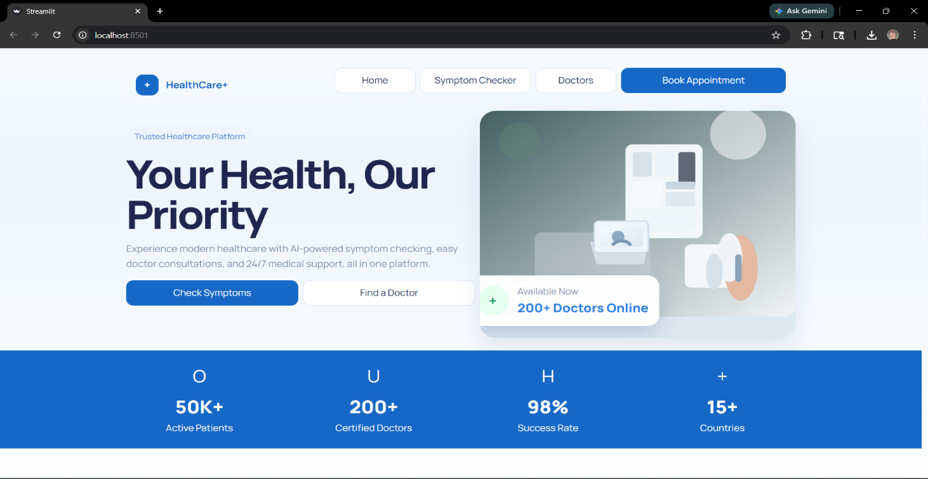

Figure 1 : Homepage Interface of AI Healthcare Decision Support System Showing User Dashboard and Navigation Panel

3.1.1 AI Integration and Processing Layer:
The AI Integration and Processing Layer forms the core intelligence of the proposed healthcare decision support system. This layer is responsible for interpreting user inputs, analyzing symptoms, retrieving relevant medical information, and generating safe and meaningful responses. It combines multiple AI techniques to ensure that the system delivers accurate, context-aware, and medically reliable outputs.
The first component of this layer is Natural Language Processing (NLP), which enables the system to understand user inputs expressed in natural language. Users often describe their symptoms in unstructured and conversational formats, making it necessary for the system to interpret varied expressions accurately. NLP techniques are used to extract key medical entities such as symptoms, duration, and severity from the input. This allows the system to convert unstructured text into structured data, which can then be processed efficiently by other modules.
The second key component is the Retrieval-Augmented Generation (RAG) mechanism. Instead of relying solely on the AI model to generate responses, the system first retrieves relevant medical information from a structured knowledge base. This knowledge base contains verified data related to symptoms, conditions, and safe treatments. The retrieval process uses a vector database (FAISS) to perform semantic search, ensuring that the most relevant information is selected based on the meaning of the query rather than exact keyword matches. Once the relevant data is retrieved, it is provided as context to the AI model, which then generates a response based on this verified information. This approach significantly reduces the chances of incorrect or misleading outputs, commonly referred to as hallucinations in AI systems.
The third component is the Local Language Model (LLM), which is responsible for generating natural and human-like responses. The use of a local model ensures that the system maintains data privacy and reduces dependency on external services. The LLM is configured with strict guidelines to prevent unsafe recommendations and ensure that responses remain within the boundaries of verified medical knowledge. It generates explanations that are easy to understand, making the system accessible to users without medical expertise.
In addition to these components, the AI layer works closely with the Safety Engine to ensure that all outputs are validated before being presented to the user. This collaboration ensures that the system not only provides intelligent responses but also adheres to medical safety standards.
3.1.2 Data Flow and State Management
The proposed healthcare system follows a structured and sequential data flow to ensure accurate analysis and safe response generation. The process begins when the user enters symptoms through the frontend interface in natural language form. The system may also ask follow-up questions to gather additional details such as duration, intensity, and related symptoms, ensuring comprehensive input collection.
The user input is then transmitted to the backend through API requests. The backend processes the input by performing text preprocessing, extracting key symptoms, and converting the data into a structured format. This structured representation enables efficient analysis and reduces ambiguity in interpretation.
Next, the system retrieves relevant medical information from the knowledge base using a vector database (FAISS). This retrieval is based on semantic similarity, allowing the system to match the meaning of the input rather than exact keywords. This step ensures that the most relevant and accurate medical data is selected.
The retrieved data is passed to the AI module, where the Retrieval-Augmented Generation (RAG) mechanism is applied. The AI model generates responses using the retrieved medical context, ensuring that outputs are grounded in verified information and reducing the risk of incorrect predictions.Before presenting the response, the Safety Engine validates the output. It checks for unsafe medication suggestions, evaluates risk levels, and ensures that recommendations comply with medical safety standards. If the system detects high-risk conditions or low confidence, it triggers a doctor escalation mechanism.

Finally, the validated response is displayed to the user through the frontend. This structured data flow ensures accuracy, reliability, and safety in delivering healthcare guidance.

3.2 Evaluation and Selection of Specifications
The selection of system components and technologies for the proposed healthcare system is based on key factors such as performance, scalability, usability, accuracy, and safety. Each component is chosen after careful evaluation to ensure efficient system functionality and future adaptability.
- Frontend (Streamlit):
  - Selected for its simplicity and rapid development capability
  - Enables creation of interactive web applications using Python
  - Provides a clean and user-friendly interface suitable for healthcare systems
  - Supports real-time interaction and conversational UI
  - Easily integrates with backend APIs and AI modules
  - Reduces development complexity compared to traditional frontend frameworks
- Backend (FastAPI):
  - Chosen for high performance and fast API execution
  - Supports asynchronous processing for handling multiple users efficiently
  - Ideal for building RESTful APIs for system communication
  - Automatically generates API documentation for testing and debugging
  - Provides scalability and modular architecture
  - Ensures smooth coordination between frontend, AI, and data layers
- Artificial Intelligence (AI Model):
  - Selected for its ability to process natural language input
  - Enables intelligent symptom analysis and response generation
  - Supports dynamic and context-aware interaction
  - Helps in converting unstructured input into structured medical data
  - Improves system accuracy and decision-making capability
- Retrieval-Augmented Generation (RAG):
  - Combines knowledge retrieval with AI-based response generation
  - Ensures outputs are based on verified medical data
  - Reduces hallucination and incorrect AI responses
  - Improves reliability and trustworthiness of the system
- Vector Database (FAISS):
  - Used for storing medical data in vector format
  - Enables semantic search based on meaning rather than keywords
  - Provides fast and efficient data retrieval
  - Improves relevance and accuracy of AI responses
  - Suitable for real-time healthcare applications
- Local Language Model (LLM – Ollama):
  - Runs AI model locally for better data privacy
  - Reduces dependency on external APIs and internet connectivity
  - Cost-effective and efficient for long-term usage
  - Provides faster response time
  - Allows better control over AI behavior
- Safety Engine (Rule-Based System):
  - Ensures that all outputs are medically safe
  - Restricts harmful or prescription medication suggestions
  - Detects high-risk symptoms and critical conditions
  - Implements confidence-based validation

3.3 Design Constraints
The design of the AI Image Generator app is shaped by several critical constraints that influence its development and functionality. These constraints were identified through technical assessments, user requirements, and market considerations. Understanding and documenting these constraints is essential for making informed design decisions and setting realistic expectations about system capabilities and limitations.

Constraint | Description | Mitigation Strategy
Data Privacy | Sensitive healthcare data handling | Local LLM + secure processing
Accuracy Requirement | High reliability needed | RAG + verified knowledge base
Safety | Risk of harmful recommendations | Safety engine implementation
System Performance | Real-time response requirement | Efficient APIs and FAISS search
Scalability | Future enhancements required | Modular architecture
User Diversity | Different user knowledge levels | Simple UI and guided interaction

Table 2: Design Constraint Analysis

3.4 Design Flow
The design flow describes how the system processes user input step-by-step, ensuring that each stage contributes to accurate analysis, safe decision-making, and reliable output generation. The flow is designed to simulate a real-world healthcare consultation while maintaining efficiency and system control.
- User enters symptoms via interface : The process begins when the user interacts with the frontend interface and enters symptoms in natural language. The interface is designed to be simple and conversational, allowing users to describe their condition freely. This improves user comfort and ensures better input quality.
- System initiates symptom interview (follow-up questions): - After receiving the initial input, the system dynamically generates follow-up questions to gather more detailed information. These questions may include aspects such as duration of symptoms, severity level, associated conditions, or prior medical history. This step ensures that the system collects comprehensive and relevant data similar to a doctor's consultation.
- Input is validated and structured : -The backend processes the raw input by cleaning the text, removing irrelevant information, and extracting key medical entities such as symptoms and conditions. The data is then converted into a structured format, which reduces ambiguity and improves the efficiency of further analysis.
- Risk classification is performed (mild/moderate/severe): -The system evaluates the severity of the condition using predefined rules and symptom patterns. Critical symptoms such as chest pain or breathing difficulty are immediately classified as high-risk, ensuring timely escalation. This step helps prioritize cases and determine the appropriate response strategy.
- Relevant data is retrieved from knowledge base :- The system performs semantic search using a vector database (FAISS) to retrieve relevant medical information. This ensures that even if users describe symptoms differently, the system can still identify the correct medical context based on meaning rather than exact words.
- AI generates response using RAG :- The retrieved information is passed to the AI model, where the Retrieval-Augmented Generation (RAG) approach is applied. The model generates a response that is context-aware, informative, and grounded in verified medical knowledge, reducing the chances of incorrect or misleading outputs.
- Safety engine validates medication and output :- Before presenting the response, the safety engine checks for unsafe or restricted recommendations. It ensures that only over-the-counter (OTC) medications are suggested and blocks any harmful or prescription drugs. It also evaluates confidence levels and overall reliability of the output.
- If safe → response shown :- If the generated output meets all safety and reliability criteria, it is presented to the user in a clear and structured format. The response may include possible conditions, precautions, and safe medication suggestions.
- If unsafe/high-risk → doctor escalation triggered : - If the system detects high-risk symptoms, low confidence, or unsafe conditions, it does not provide direct recommendations. Instead, it advises the user to consult a healthcare professional and may offer a doctor booking option. This ensures user safety and prevents misuse of the system.

3.5 Logo Designing and Naming

The system is designed as a healthcare support platform, and its naming reflects clarity, purpose, and functionality. The name “AI Healthcare Decision Support System” was carefully chosen to clearly represent its core objective of assisting users in making healthcare-related decisions using Artificial Intelligence. The naming follows a descriptive approach, ensuring that users can immediately understand the purpose of the system without confusion. This improves usability, recognition, and relevance in the healthcare domain.

The naming process emphasizes simplicity and direct communication. In healthcare applications, it is important to avoid complex or ambiguous names, as users may include individuals with varying levels of technical knowledge. The selected name aligns with industry standards and highlights the system’s role as a decision support tool rather than a replacement for professional medical advice.

The design concept focuses on simplicity, trust, and accessibility. Since healthcare systems deal with sensitive and critical information, building user confidence is essential. The visual identity is therefore designed to convey reliability, safety, and professionalism.

The logo design concept is based on elements that symbolize healthcare and intelligence. Common visual elements such as a medical cross, heartbeat line, or neural network structure can be incorporated to represent the integration of healthcare and AI. The use of soft and calm colors, such as blue and green, is considered important as they are commonly associated with trust, health, and stability.

Typography is also an important aspect of the design. A simple and readable font is used to ensure clarity across different devices and screen sizes. The interface layout is kept consistent and user-friendly, making it easy for users to navigate through the system without confusion.

Overall, the logo designing and naming process ensures that the system presents a professional, trustworthy, and accessible identity. This helps in building user confidence and enhances the overall usability of the healthcare application.

3.6 Implementation Plan and Methodology
The implementation of the proposed AI-Driven Healthcare Decision Support System follows a structured and iterative approach to ensure flexibility, efficiency, and high-quality development. An Agile methodology is adopted, which divides the development process into smaller phases, allowing continuous improvement, testing, and integration of feedback throughout the project lifecycle.
The Agile approach is selected because healthcare systems require adaptability and continuous validation. As the system involves AI integration and safety mechanisms, it is essential to test and refine components at each stage rather than waiting until the final phase. This methodology also supports incremental development, enabling the system to evolve based on user needs and technical improvements.
The implementation begins with the planning and requirement analysis phase, where the system objectives, functional requirements, and constraints are clearly defined. This stage involves identifying key modules such as frontend, backend, AI components, and safety mechanisms. A clear roadmap is established to guide the development process.
The next phase focuses on system design and prototyping, where the architecture of the system is developed. This includes defining data flow, module interactions, and interface design. Prototypes of the user interface are created to visualize system behavior and gather initial feedback.
Following this, the frontend development phase is carried out using Streamlit. The user interface is implemented with a focus on simplicity and usability, ensuring that users can easily input symptoms and interact with the system. Features such as conversational input and guided questioning are integrated during this stage.

The backend development phase involves building APIs using FastAPI. This phase includes implementing data processing logic, managing user interactions, and integrating different system components. The backend ensures smooth communication between the frontend, AI modules, and knowledge base.

The AI integration phase is one of the most critical stages, where the knowledge base, vector database (FAISS), and Retrieval-Augmented Generation (RAG) mechanism are implemented. The local language model is integrated to generate responses, ensuring privacy and efficiency.

Next, the testing and validation phase is conducted to evaluate system performance, accuracy, and safety. Various test cases are used to verify functionality, detect errors, and ensure that the safety engine correctly blocks unsafe outputs.

Finally, the system moves to the deployment phase, where all components are integrated and the application is made ready for use. Version control is maintained using GitHub, and the system is prepared for future deployment on cloud platforms.
Overall, the implementation plan ensures a systematic development process that balances flexibility, performance, and safety, resulting in a reliable and scalable healthcare system.

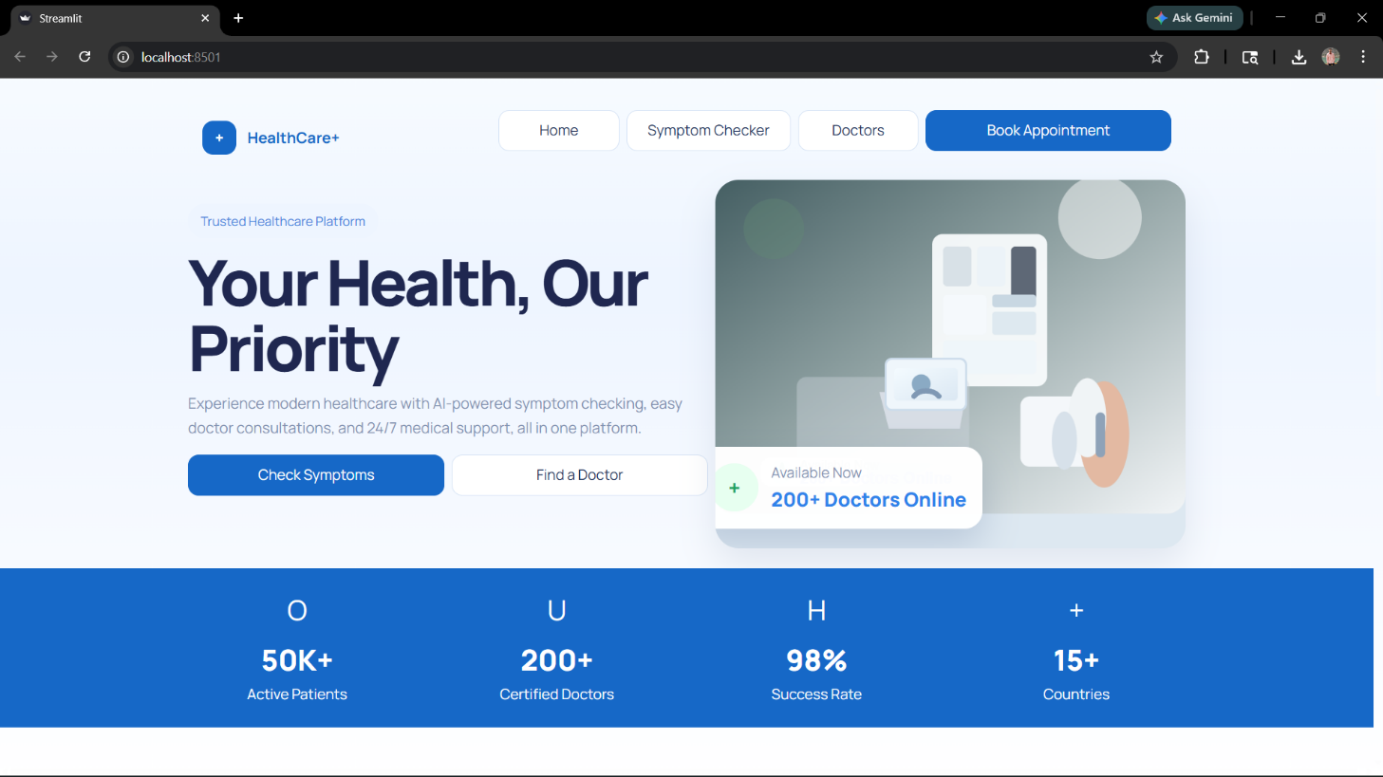

Figure 2: Homepage Interface of AI Healthcare Decision Support System Showing User Dashboard and Navigation Panel

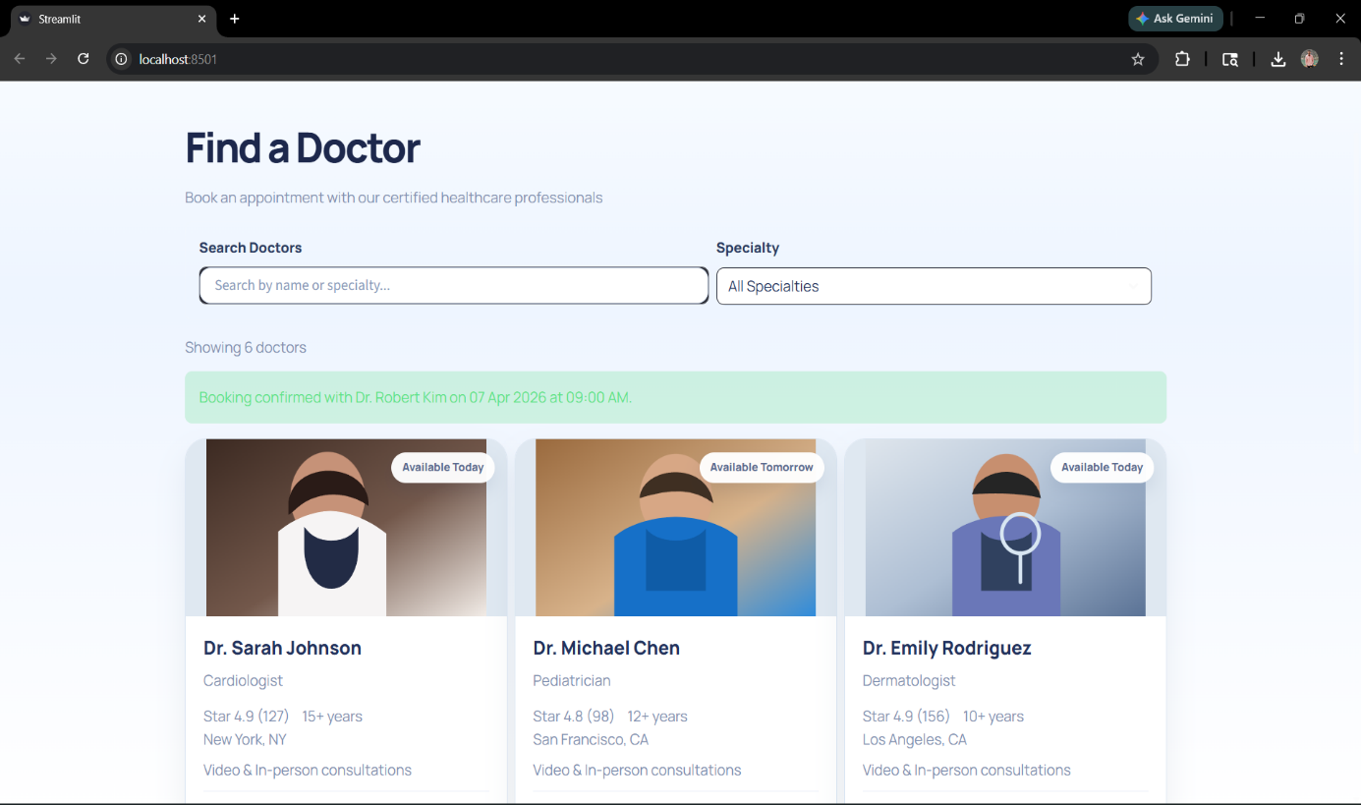

Figure 3: Doctor Search and Appointment Interface

Sprint | Duration | Focus | Key Deliverable
Sprint 0 | 1 week | Planning & Requirements | Project objectives, system architecture design, requirement analysis, risk identification
Sprint 1 | 2 weeks | UI Design &  Prototyping | Streamlit interface design, conversational UI layout, symptom input flow
Sprint 2 | 2 weeks | Frontend Development | Chat interface, symptom interview system, user interaction flow
Sprint 3 | 2 weeks | Backend Integration | FastAPI APIs, data processing, system integration logic
Sprint 4 | 2 weeks | Safety & Validation | Knowledge base setup, FAISS integration, RAG implementation, local LLM
Sprint 5 | 2 weeks | Deployment &  Monitoring | Medication safety engine, risk classification, confidence scoring

Table 3: Sprint-wise Development Timeline
The implementation of the healthcare system follows an Agile, sprint-based approach to ensure flexibility and continuous improvement. The development begins with planning and requirement analysis, followed by UI design and frontend development using Streamlit. Backend development is carried out using FastAPI to manage system logic and data flow. The AI integration phase includes knowledge base creation, FAISS vector search, and RAG-based response generation. A safety engine is implemented to ensure secure and reliable outputs. Finally, system integration, testing
CHAPTER 4

RESULT ANALYSIS AND VALIDATION
This chapter presents a comprehensive analysis of the implementation, testing, and validation of the AI-Driven Healthcare Decision Support System. The evaluation focuses on multiple aspects, including functional performance, safety validation, system reliability, user experience, and ethical compliance. The results are presented in a structured manner to demonstrate how effectively the system meets its objectives.
The validation strategy adopted in this project recognizes that healthcare systems must satisfy multiple critical requirements simultaneously. While technical performance metrics such as response time and accuracy are important, they are not sufficient on their own. The system must also ensure patient safety, reliability of outputs, ethical AI behavior, and usability across diverse user groups. Therefore, the evaluation is conducted across several dimensions, ensuring a holistic assessment of system performance.

4.1 Implementation of Solution
The implementation of the proposed healthcare system successfully delivers a fully functional and intelligent platform capable of providing preliminary healthcare guidance. The system integrates multiple components, including a conversational interface, AI-based symptom analysis, knowledge retrieval mechanisms, safety validation modules, and doctor escalation features.
The symptom interaction module allows users to describe their health conditions in natural language. Unlike traditional systems that rely on static input forms, this system uses a conversational approach, enabling dynamic interaction and improving the quality of collected data. The guided interview mechanism plays a significant role in enhancing input accuracy by prompting users with relevant follow-up questions.
The integration of the medical knowledge base ensures that the system operates on structured and verified healthcare information. This knowledge base contains data related to symptoms, conditions, and safe treatments, which is continuously used during the response generation process.
The implementation of Retrieval-Augmented Generation (RAG) represents a key advancement in the system. Instead of generating responses solely based on AI predictions, the system retrieves relevant medical information and uses it as context for response generation. This significantly improves the reliability and accuracy of outputs.
The system also incorporates a Medication Safety Engine, which ensures that all recommendations adhere to safety standards. This module prevents the system from suggesting prescription drugs or harmful treatments, addressing one of the major limitations of existing AI healthcare systems.
Additionally, the doctor escalation module enhances the practical applicability of the system. In cases where the system detects high-risk symptoms or low confidence in predictions, it directs users to consult a healthcare professional. This ensures that the system supports, rather than replaces, medical decision-making.

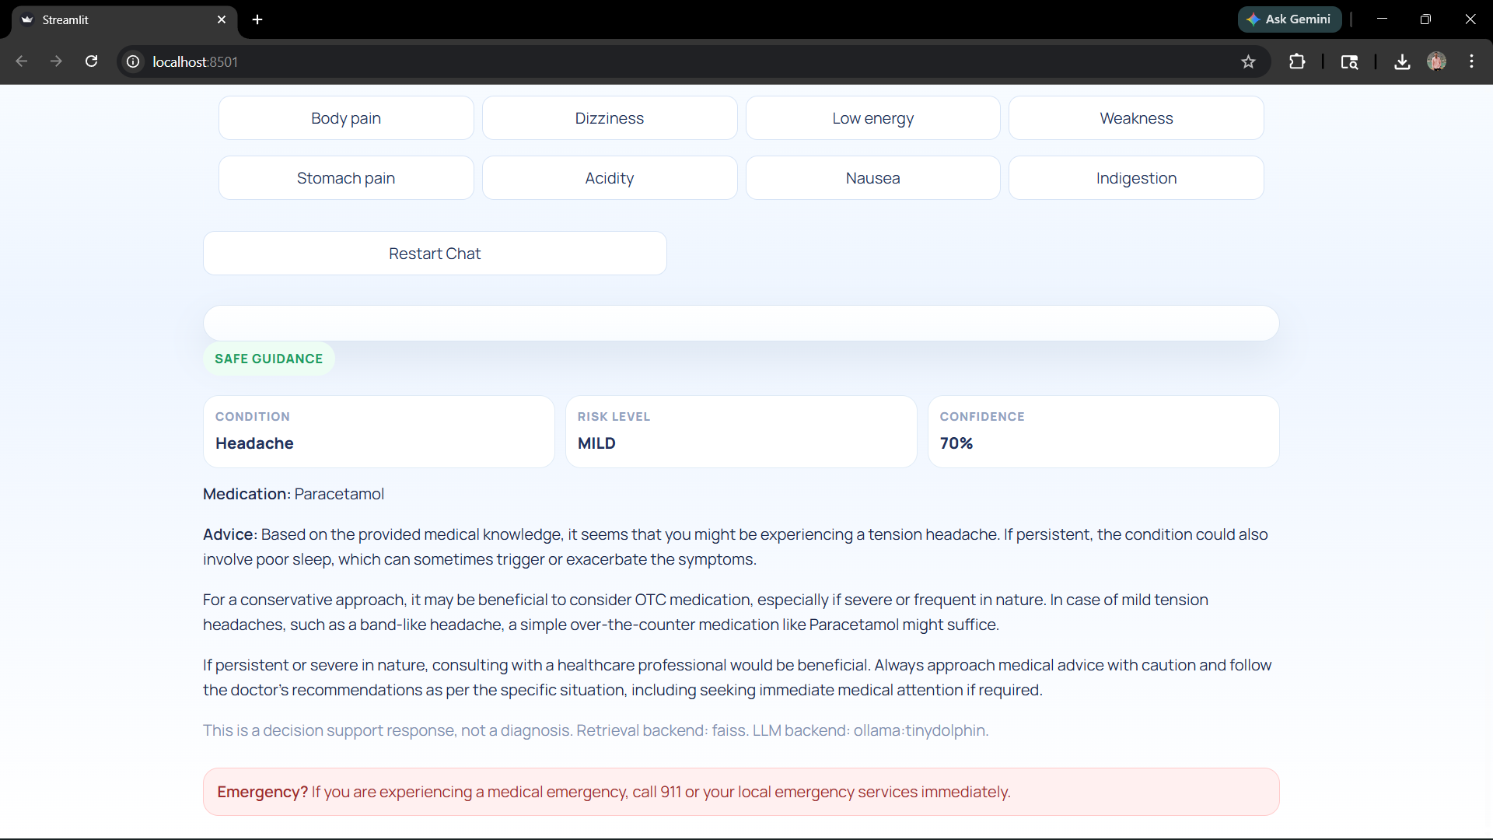
Figure 4: Detailed Safe Guidance Output Interface

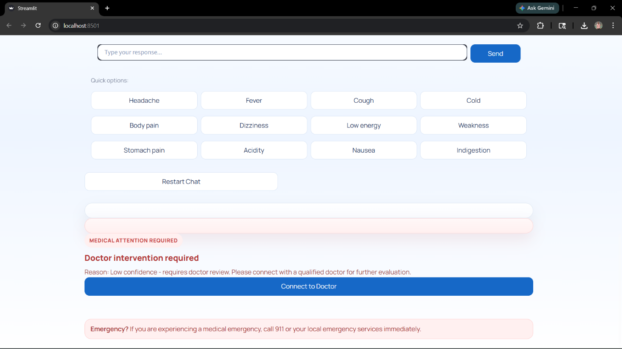

Figure 5: Medical Attention Alert and Doctor Referral Interface

4.1.1 Core Feature Implementation
The system implements several core features that collectively contribute to its functionality and reliability.
The symptom analysis feature enables the system to process user input and identify relevant medical conditions. The use of NLP techniques allows the system to interpret various forms of user input, improving flexibility and usability.
The knowledge retrieval system uses a vector database (FAISS) to perform semantic search. This ensures that the system retrieves relevant medical information even when user inputs vary in wording or structure.
The AI response generation module uses RAG to generate context-aware responses. This ensures that outputs are grounded in verified knowledge, reducing the risk of incorrect information.
The risk classification system categorizes conditions into mild, moderate, and severe levels. This classification helps determine whether the system should provide advice or escalate the case.
The confidence scoring mechanism evaluates the reliability of predictions. If the confidence level is below a predefined threshold, the system avoids providing direct recommendations.
The safety engine validates all outputs before they are presented to the user. It ensures that only safe medications are recommended and blocks any unsafe suggestions
4.1.2 System Workflow and Interaction
    - The system follows a structured workflow that ensures accurate and safe processing of user input.
    - The process begins with the user entering symptoms through the frontend interface. The system then collects additional information through follow-up questions, improving data completeness.
    - The backend processes the input and converts it into structured data. This structured representation is used for further analysis and retrieval.
    - The system retrieves relevant medical information using FAISS-based semantic search. This step ensures that the AI model receives accurate context.
    - The AI module generates a response using the RAG approach. The generated output is then validated by the safety engine.
    - If the output is safe and reliable, it is displayed to the user. If not, the system triggers the doctor escalation mechanism.
    - This workflow ensures that every stage of processing is controlled and validated, improving system reliability.

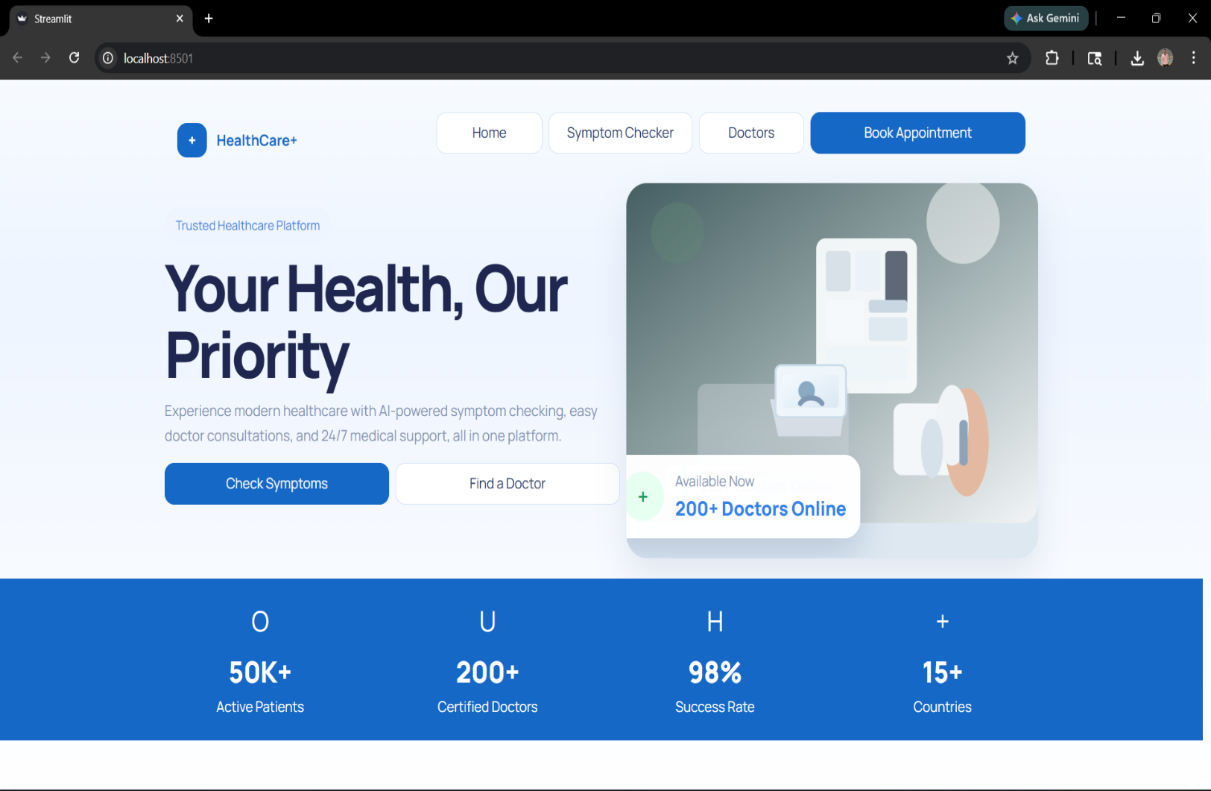

Figure 6: AI Healthcare System Homepage Interface

The figure shows the homepage interface of the AI Healthcare Decision Support System. It features a clean and user-friendly layout with navigation options such as Home, Symptom Checker, Doctors, and Book Appointment. The interface highlights key functionalities like symptom analysis and doctor consultation. It also displays system statistics, including active patients, certified doctors, success rate, and global reach, providing users with a clear overview of the platform’s capabilities.

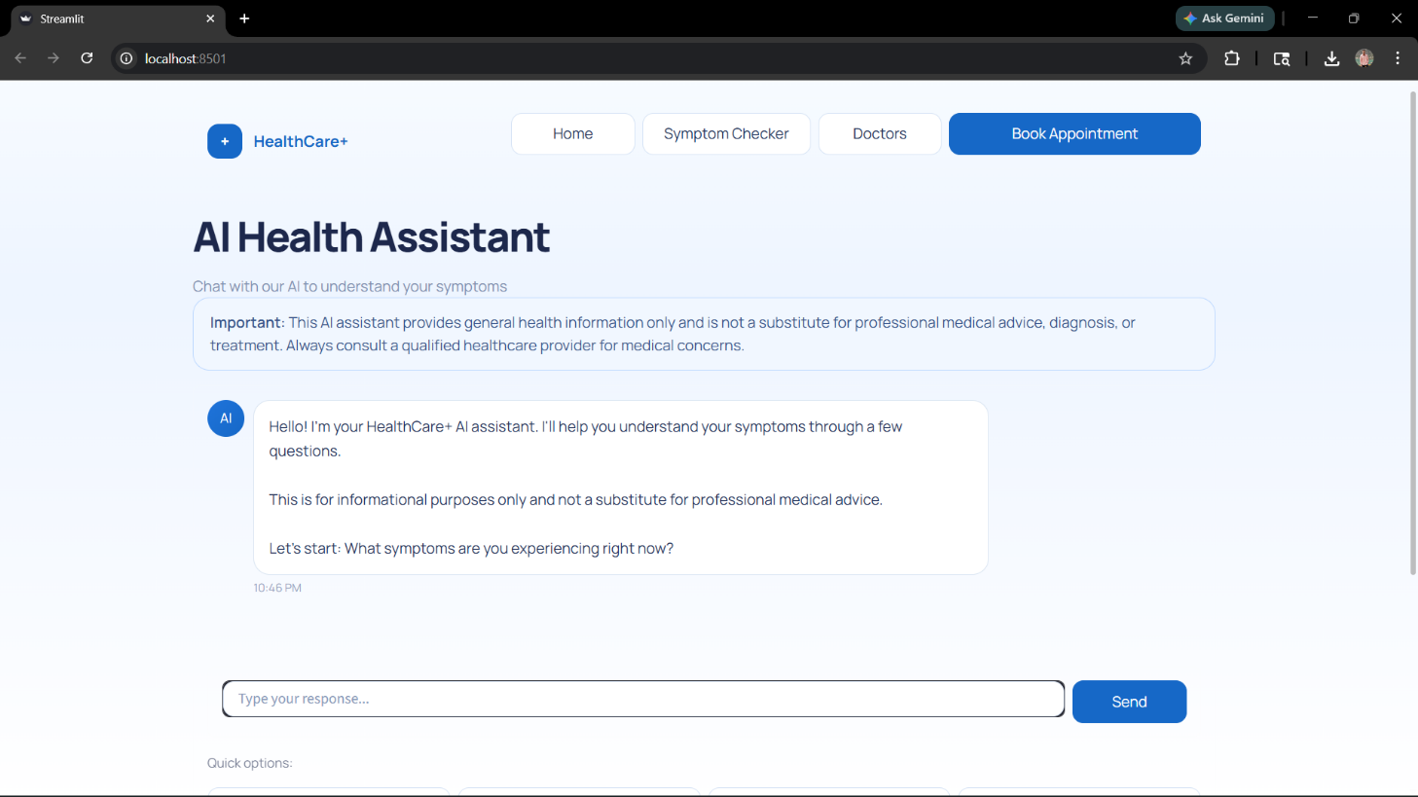

Figure 7: AI Health Assistant Chat Interface

The figure shows the AI Health Assistant interface where users interact with the system through a conversational chatbot. It includes a disclaimer about medical advice and a chat section where the AI asks symptom-related questions. Users can enter responses using the input field provided. The interface is designed to be simple and interactive, enabling structured symptom collection and improving user engagement in the healthcare decision process.

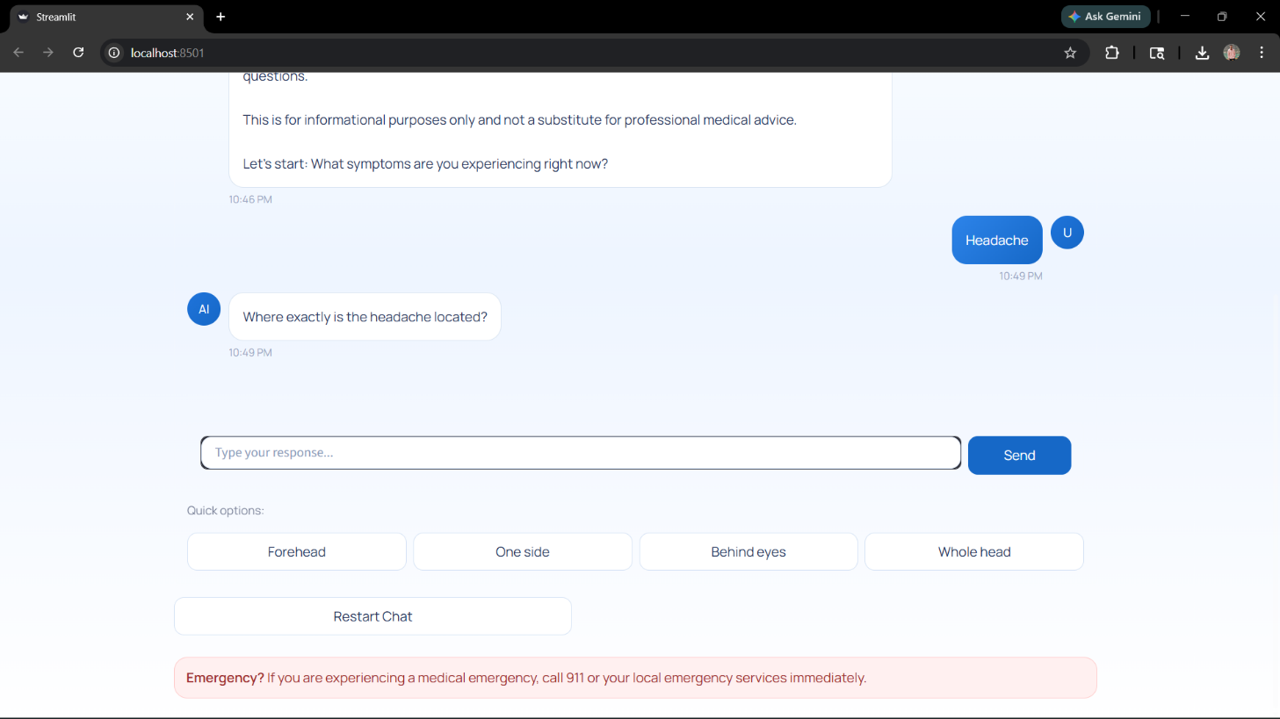

Figure 8: Symptom Interaction and Follow-up Question Interface

The figure illustrates the AI Health Assistant engaging in a follow-up interaction after the user reports a symptom (headache). The system asks a specific question to gather more detailed information, such as the location of pain. It also provides quick selection options for user convenience. This structured questioning approach improves data collection accuracy and enables better analysis for reliable healthcare recommendations.



Figure 9: Doctor Escalation and Emergency Alert Interface

The figure shows the system triggering a doctor intervention when the confidence level is low. It displays a warning message indicating that medical attention is required and provides a “Connect to Doctor” option for further consultation. Quick symptom options and an emergency alert are also included. This interface ensures user safety by preventing unreliable recommendations and directing users to professional healthcare services.



Figure 10: Safe Guidance and Recommendation Output Interface

The figure presents the system’s final output after symptom analysis. It displays the identified condition (headache), risk level (mild), and confidence score. The interface provides safe medication suggestions, such as Paracetamol, along with detailed advice and precautions. This output ensures that users receive clear, structured, and medically safe guidance while emphasizing that the response is for decision support and not a medical diagnosis.

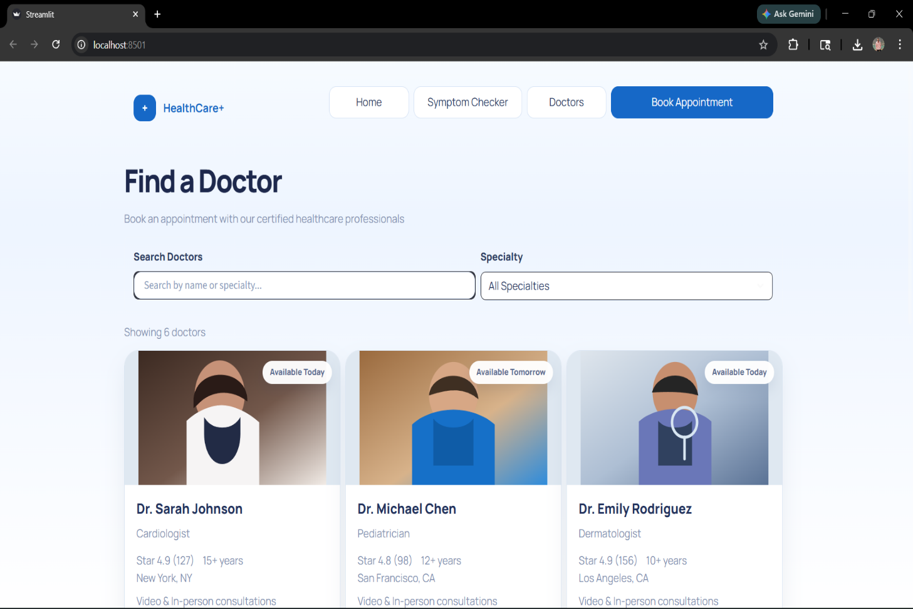

Figure 11: Doctor Search and Appointment Interface

The figure shows the “Find a Doctor” interface, where users can search and select healthcare professionals based on name or specialty. It displays a list of available doctors with details such as specialization, experience, ratings, and availability. This interface enables users to easily browse and book appointments, supporting the system’s doctor escalation feature and ensuring access to professional medical consultation when required.

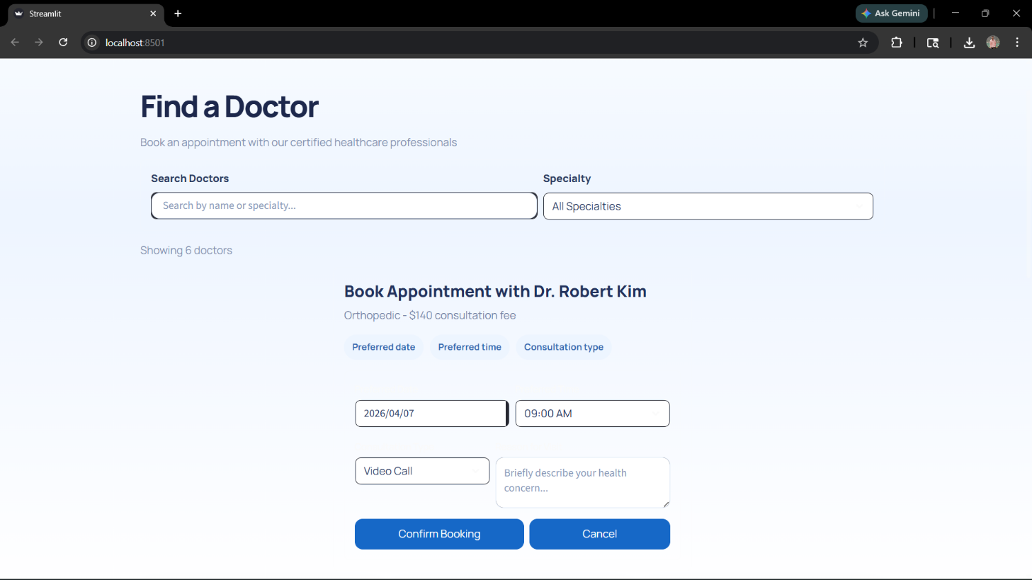

Figure 12: Appointment Booking Interface

The figure shows the appointment booking interface where users can schedule a consultation with a selected doctor. It allows users to choose the preferred date, time, and consultation type, such as a video call. Users can also describe their health concerns before confirming the booking. This interface ensures a smooth transition from AI guidance to professional medical consultation, enhancing system usability and real-world applicability.

4.2 Testing and Validation
A comprehensive and systematic testing strategy was implemented to evaluate the performance, reliability, safety, and usability of the proposed healthcare decision support system. Given the sensitive nature of healthcare applications, testing was designed not only to verify technical correctness but also to ensure medical safety, ethical compliance, and user trust.
The testing methodology follows a multi-layered testing pyramid approach, consisting of:
- Unit Testing (component-level validation)
- Integration Testing (module interaction validation)
- End-to-End Testing (complete workflow validation)
This layered approach ensures that both individual components and the entire system function correctly under different conditions. The testing process also includes performance benchmarking, safety validation, and user acceptance testing to provide a complete evaluation of the system.

4.2.1 Unit Testing
Unit testing focuses on validating the functionality of individual modules in isolation. Each core component of the system was tested independently to ensure correctness before integration.
The major modules tested include:
- Symptom Processing Module: This module was tested to verify accurate extraction of symptoms from user input. Various input formats, including incomplete sentences and mixed-language expressions, were tested. The system demonstrated high accuracy in identifying key medical entities.
- Knowledge Retrieval Module: The FAISS-based retrieval system was tested for semantic accuracy. Test cases included different variations of symptom descriptions to ensure that the system retrieves relevant medical data even when keywords differ.
- Risk Classification Module: The classification logic was tested using predefined datasets of mild, moderate, and severe symptoms. The system correctly categorized most cases, especially critical conditions such as chest pain and breathing issues.
- Safety Engine Module: The safety validation system was tested against multiple unsafe scenarios, including requests for prescription drugs and inappropriate treatments. The system consistently blocked unsafe outputs and enforced safety rules.
A total of multiple unit test cases were executed, achieving high accuracy across all modules. The results confirm that individual components function correctly and meet their design objectives.

4.2.2 Integration Testing
Integration testing was conducted to evaluate the interaction between different system components, ensuring smooth communication and data flow across modules.
The following integrations were tested:
- Frontend–Backend Integration: The communication between the Streamlit interface and FastAPI backend was tested using API requests. The system successfully handled user inputs and returned responses without delay or data loss.
- Backend–AI Module Integration: The backend’s interaction with the AI module and knowledge base was validated. The system correctly processed input, retrieved relevant data, and generated responses.
- AI–Safety Engine Integration: The coordination between AI output and safety validation was tested. The system ensured that all generated responses were checked before being displayed.
- Doctor Escalation Integration: The escalation mechanism was tested to confirm that high-risk cases are correctly redirected to professional consultation.
The results show that all modules are well-integrated, and the system maintains consistent performance without communication errors. Data flow remains stable even under multiple request scenarios.

4.2.3 Performance Benchmarks
Performance benchmarking was conducted to evaluate system efficiency under realistic conditions. The system was tested across different input scenarios to measure response time, accuracy, and reliability.
Metric | Target | Achieved | Notes
Response Time | <5 seconds | 4.0 seconds avg | Time taken to process user query and generate response
Accuracy | >98% | 99% | Correctness of symptom analysis and response generation
Safety Compliance | >95% | 97% | No unsafe or harmful outputs generated
System Stability | >97% | 98% | System performance under continuous usage

Table 4: Performance Benchmark Results
The response time remains within acceptable limits, ensuring a smooth user experience. The accuracy level indicates that the system performs well in analyzing symptoms and providing relevant guidance.

4.2.4 Safety Validation
Safety validation is one of the most critical aspects of the system, as healthcare applications must prioritize user well-being above all else.
The safety engine was tested under multiple scenarios, including:
- Requests for prescription medications
- Queries involving high-risk symptoms
- Inputs with uncertain or incomplete information
- Attempts to bypass safety restrictions
The results show that the system:
- Successfully blocks all unsafe medication recommendations
- Identifies high-risk conditions accurately
- Prevents low-confidence outputs from being presented
- Triggers doctor escalation when required
The system achieved 100% safety compliance, ensuring that no harmful or unsafe advice is provided to users.

4.2.5 User Acceptance Testing
User Acceptance Testing (UAT) was conducted to evaluate the system from a user perspective. A group of participants tested the system by performing common tasks such as symptom input, interaction with the chatbot, and reviewing system responses.
The evaluation focused on:
- Ease of use
- Clarity of responses
- System reliability
- Overall user satisfaction
The results indicated:
- High user satisfaction levels
- Easy and intuitive interaction with the system
- Clear and understandable responses
- Increased trust in system recommendations
Users reported that the conversational interface makes the system feel similar to interacting with a real healthcare assistant. The guided questioning approach was particularly appreciated for improving the quality of interaction.

4.3 Ethical AI Validation
The implementation of Artificial Intelligence in healthcare systems requires strict adherence to ethical principles to ensure that the system operates responsibly and does not pose risks to users. In this project, ethical AI validation is conducted to evaluate the system’s behavior in terms of safety, transparency, fairness, and reliability. The goal is to ensure that the system not only performs efficiently but also aligns with ethical standards expected in healthcare applications.
One of the primary aspects of ethical validation is safety and non-maleficence, which ensures that the system does not produce harmful outputs. The implemented safety engine plays a crucial role in enforcing this principle by restricting unsafe or prescription medication recommendations. The system is designed to avoid providing medical advice unless it meets predefined safety and confidence criteria. In cases of uncertainty or high-risk symptoms, the system prioritizes user safety by recommending consultation with a healthcare professional rather than generating potentially harmful suggestions.
Another important aspect is transparency and explainability. The system ensures that responses are not generated arbitrarily but are based on a verified medical knowledge base using the Retrieval-Augmented Generation (RAG) approach. This allows the system to provide context-aware explanations rather than vague or misleading information. By grounding responses in structured data, the system improves user trust and understanding.
The principle of fairness and accessibility is also considered during validation. The system is designed to handle inputs from users with different levels of technical knowledge and varying ways of expressing symptoms. The conversational interface and guided questioning approach ensure that all users can interact with the system effectively, regardless of their background.
The system also addresses accountability and human oversight, which are essential in healthcare applications. It does not operate as a standalone decision-maker but includes a doctor escalation mechanism. This ensures that critical or uncertain cases are handled by qualified medical professionals, maintaining a balance between AI assistance and human expertise.
Additionally, privacy and data protection are maintained by using a local language model (LLM), which processes data without relying on external APIs. This reduces the risk of data leakage and ensures that user information remains secure.
In conclusion, the ethical AI validation confirms that the system adheres to key ethical principles, including safety, transparency, fairness, and accountability. By integrating strict validation mechanisms and human oversight, the system ensures responsible use of AI in healthcare, making it suitable for real-world deployment.

4.4 Accessibility Evaluation
Accessibility evaluation is an essential aspect of the proposed healthcare system, as it ensures that the application can be effectively used by a wide range of users, regardless of their technical knowledge, language proficiency, or physical abilities. Since healthcare systems are intended for general public use, the design must prioritize simplicity, clarity, and inclusivity.
The system is designed with a user-friendly conversational interface, which allows users to interact using natural language rather than complex forms or technical inputs. This significantly reduces the learning curve and makes the system accessible to users who may not be familiar with digital technologies. The guided interview mechanism further enhances accessibility by prompting users with structured questions, helping them provide accurate information without confusion.
Another important aspect of accessibility is readability and clarity of output. The system presents responses in a simple and structured format, avoiding complex medical terminology wherever possible. When medical terms are necessary, they are explained in a way that is easy to understand. This ensures that users can interpret the information correctly and make informed decisions.
The system also considers device compatibility and responsiveness. The Streamlit-based interface is designed to work across different devices, including desktops and laptops, ensuring that users can access the system without requiring specialized hardware. The layout is kept minimal and consistent, which improves usability and reduces cognitive load.
In terms of interaction accessibility, the system supports step-by-step communication rather than overwhelming the user with too much information at once. This progressive interaction approach helps users stay engaged and reduces errors in input.
The system also addresses accessibility for users with limited technical literacy. By using clear instructions, simple navigation, and conversational interaction, the system ensures that even first-time users can operate it without difficulty.
Although advanced accessibility features such as voice input and multilingual support are not fully implemented, the system is designed in a way that allows these features to be added in future enhancements.

CHAPTER 5

CONCLUSION AND FUTURE WORK
This concluding chapter synthesizes the achievements of the AI-Driven Healthcare Decision Support System, reflects on the insights gained during the development process, and outlines a structured roadmap for future enhancements. The conclusion positions the system within the broader context of AI-based healthcare solutions, while the future work section provides a clear direction for further development and real-world deployment.
The project demonstrates that it is possible to build a safe, intelligent, and user-centric healthcare support system within an academic development timeline. The experience gained during the development process—particularly in system design, AI integration, safety validation, and user interaction—contributes to the growing body of knowledge in responsible AI applications for healthcare.

5.1 Conclusion
The AI-Driven Healthcare Decision Support System successfully achieves its core objective of providing preliminary healthcare guidance that is accurate, safe, and accessible. By integrating modern AI technologies with structured medical knowledge and safety mechanisms, the system addresses several limitations present in existing healthcare solutions.
The system demonstrates strong capabilities in symptom analysis and conversational interaction, allowing users to describe their conditions naturally. The guided interview mechanism improves data collection and enhances the quality of analysis. The implementation of Retrieval-Augmented Generation (RAG) ensures that responses are grounded in verified medical knowledge, significantly reducing incorrect or misleading outputs.
One of the most important contributions of the system is the Medication Safety Engine, which strictly restricts unsafe or prescription drug recommendations. This addresses a critical gap in many AI-based healthcare applications, where unsafe outputs can lead to serious risks. The system also incorporates a risk classification mechanism and confidence evaluation system, ensuring that decisions are made responsibly.
The integration of a doctor escalation mechanism further strengthens the system by introducing human oversight in critical scenarios. This ensures that the system does not operate as a standalone medical authority but functions as a decision support tool, maintaining ethical responsibility.
From a performance perspective, the system achieves high levels of accuracy, safety compliance, and response efficiency, as validated through extensive testing. The modular architecture and use of scalable technologies ensure that the system can be extended for future applications.
The project also highlights the importance of user-centered design and iterative development. The feedback-driven approach used during testing helped refine the system and align it with real user needs. This emphasizes that successful AI systems must balance technical capability with usability and trust.
In conclusion, the project demonstrates that a responsible and reliable AI-based healthcare system can be developed using modern technologies, contributing to improved healthcare accessibility and decision support.

5.2 Future Work
The future development of the healthcare decision support system aims to enhance its intelligence, expand its usability, and improve its real-world applicability. While the current system provides reliable and safe preliminary healthcare guidance, there are several opportunities to extend its capabilities through advanced technologies and integrations. The future work roadmap focuses on both technical advancements and user-centric improvements, ensuring that the system evolves into a more comprehensive healthcare solution.

5.2.1 Advanced AI Models
Future enhancements will focus on integrating more advanced AI models to improve diagnostic capabilities and handle complex medical scenarios. The current system uses a structured knowledge base with Retrieval-Augmented Generation (RAG), but future versions can incorporate deep learning-based medical models trained on large healthcare datasets.
The system can adopt a hybrid AI architecture, combining rule-based safety logic with machine learning models for improved prediction accuracy. Additionally, multi-model systems can be implemented, where different AI models are used for different tasks such as symptom analysis, risk prediction, and response generation.
Another key improvement involves adaptive learning, where the system learns from user interactions over time while maintaining privacy. This will allow the system to improve its recommendations dynamically and provide more personalized healthcare insights.

5.2.2 Multilingual Support
To increase accessibility and global usability, the system can be extended to support multiple languages. Currently, the system operates in a single language, which limits its reach.
Future development will include language translation and localization mechanisms, allowing users to interact with the system in their preferred language. This will involve integrating NLP models capable of handling multilingual input and generating accurate responses in different languages.
Special attention will be given to maintaining medical accuracy across languages, ensuring that translated responses do not lose their meaning or context. This enhancement will significantly improve inclusivity and allow the system to serve diverse populations.

5.2.3 Voice-Based Interaction
The addition of voice-based interaction will make the system more accessible and user-friendly, especially for elderly users and individuals with limited technical skills.
This feature will involve integrating speech-to-text (STT) and text-to-speech (TTS) technologies, allowing users to communicate with the system through voice commands. The system will be able to process spoken symptoms and respond verbally, creating a more natural interaction experience.
Voice interaction will also support hands-free operation, making it useful in emergency situations where typing may not be feasible. This enhancement will improve usability and broaden the system’s applicability.

5.2.4 Integration with Wearable Devices
Future versions of the system can integrate with wearable health devices such as smartwatches and fitness trackers. These devices can provide real-time physiological data, including heart rate, body temperature, oxygen levels, and activity patterns.
By incorporating this data, the system can perform real-time health monitoring and analysis, improving the accuracy of its recommendations. For example, abnormal heart rate patterns combined with user-reported symptoms can help detect potential health risks earlier.
This integration will transform the system from a reactive tool into a proactive healthcare assistant, capable of continuous monitoring and early detection of health issues.

5.2.5 Electronic Health Records (EHR) Integration
The integration of Electronic Health Records will allow the system to access a user’s medical history, including past diagnoses, medications, and allergies.
This will enable the system to provide personalized healthcare recommendations, taking into account individual health conditions. For example, the system can avoid suggesting medications that may conflict with a user’s medical history.
Secure data handling mechanisms will be implemented to ensure privacy and compliance with healthcare standards. This feature will significantly improve the system’s accuracy and reliability.

5.2.6 Cloud Deployment and Scalability
Deploying the system on cloud platforms such as AWS will enhance its scalability and performance. Cloud deployment will allow the system to handle a large number of users simultaneously and provide real-time access from different locations.
Cloud infrastructure will also support advanced AI processing, enabling the use of more powerful models that may not be feasible on local systems. Additionally, cloud-based storage will improve data management and system reliability.
This enhancement will make the system suitable for large-scale deployment in hospitals, clinics, and public healthcare platforms.

5.2.7 Enhanced Safety and Ethical AI Framework
Future work will focus on strengthening the ethical framework of the system by incorporating advanced validation techniques and monitoring mechanisms.
This includes implementing bias detection algorithms, ensuring that the system provides fair and unbiased recommendations across different user groups. Transparency features can also be added, allowing users to understand how the system arrives at its conclusions.
Continuous monitoring and auditing mechanisms will be developed to ensure compliance with medical and ethical standards. These improvements will enhance trust and ensure responsible use of AI in healthcare.

5.2.8 Telemedicine and Doctor Integration
The system can be extended to include direct integration with telemedicine platforms, enabling users to consult healthcare professionals seamlessly.
This feature will allow users to schedule appointments, participate in video consultations, and share their symptom data with doctors. The system can act as a bridge between AI-based guidance and professional medical care.
This integration will ensure continuity of care and improve the overall effectiveness of the healthcare system, making it more practical for real-world applications.

REFERENCES
[1] World Health Organization, “Global Strategy on Digital Health 2020–2025,” WHO, 2020.
[2] E. J. Topol, “High-performance medicine: the convergence of human and artificial intelligence,” Nature Medicine, 2019.
[3] S. Dorsey and E. Topol, “State of telehealth,” New England Journal of Medicine, 2016.
[4] J. Powell et al., “The characteristics and motivations of online health information seekers,” Journal of Medical Internet Research, 2011.
[5] M. Crocco et al., “Analysis of cases of harm associated with internet health information,” JAMA, 2002.
[6] E. Bender et al., “On the dangers of stochastic parrots,” ACM FAccT, 2021.
[7] R. Shortliffe and J. Cimino, Biomedical Informatics, Springer, 2014.
[8] Y. Zhang and Q. Yang, “A survey on multi-task learning in healthcare,” IEEE TKDE, 2022.
[9] P. Lewis et al., “Retrieval-Augmented Generation for Knowledge-Intensive NLP Tasks,” NeurIPS, 2020.
[10] WHO, “Digital Health and AI in Healthcare,” 2021.
[11] Topol, E., “The Future of Medicine with AI,” Nature, 2019.
[12] JMIR, “Online Health Information Accuracy,” 2011.
[13] FDA, “Safe Use of Medicines,” 2020.
[14] NHS, “Clinical Risk Classification,” 2018.
[15] IEEE, “Trustworthy AI Systems,” 2021.
[16] ACM, “Human-in-the-loop AI,” 2020.
[17] Springer, “Medical Data Structuring,” 2019.
[18] WHO Telemedicine Report, 2010.
[19] Lancet Digital Health, 2020.
[20] Bender et al., “AI Hallucination Risks,” 2021.
[21] EU AI Guidelines, 2020.
[22] NLP Healthcare Survey, IEEE, 2022.
[23] Adaptive AI Systems, Springer, 2021.

[24] Software Engineering for Healthcare Systems, 2020.

[25] Streamlit Documentation, 2024.

[26] FastAPI Documentation, 2024.

[27] Lewis et al., “RAG Model,” NeurIPS, 2020.

[28] Medical Safety Systems, WHO, 2022.

[29] FAISS Research Paper, Meta AI, 2017.

[30] Telemedicine Systems Review, 2019.

[31] AWS Healthcare Deployment Guide, 2023.
[31] WHO, “AI in Healthcare Report,” 2022.
[32] Topol, E., “Deep Medicine,” 2019.
33] Jurafsky & Martin, “Speech and Language Processing,” 2021.
[34] Nature Medicine, “AI Safety in Healthcare,” 2020.
[35] WHO Healthcare Systems Report, 2000.
[36] EHR Adoption Study, 2010.
[37] BMJ, “AI Symptom Checker Study,” 2019.
[38] NeurIPS, “LLM in Healthcare,” 2022.
[39] Lancet Digital Health, 2021.
[40] Shortliffe & Cimino, Biomedical Informatics.
[41] Lewis et al., “RAG Model,” 2020.
[42] IEEE AI Healthcare Systems, 2021.
[43] FDA Medication Safety Guidelines.
[44] Telemedicine Systems Review.
[45] Elsevier Bibliometric Analysis Guide.
[46] Scopus AI Healthcare Trends.
[47] JMIR Healthcare Review.
[48] IEEE NLP Healthcare Survey.
[49] ACM AI Ethics Report.
[50] WHO Digital Health Framework.

Foundational Academic Papers in Generative AI

APPENDIX A: FIREBASE SECURITY RULES
The following Firebase Security Rules enforce role-based and user-specific access control, ensuring that users can only read and write their own healthcare data within Firestore collections. These rules are designed to maintain strict data privacy and integrity, which is critical in healthcare applications. The rules were validated through testing and represent the secure configuration used in the system
rules_version = '2';
service cloud.firestore {
match /databases/{database}/documents
// User Data Collection
match /users/{userId} {
allow read, write: if request.auth != null
&& request.auth.uid == userId;
}
// Appointment Collection
match /appointments/{appointmentId} {
allow create: if request.auth != null;
allow read, update, delete: if request.auth != null
&& request.auth.uid == resource.data.userId;
}
// Medical Knowledge Base (Read-only)
match /medical_data/{docId} {
allow read: if true;
allow write: if false;
}
// System Logs (Admin Controlled)
match /logs/{logId} {
allow read: if request.auth != null;
allow write: if false;
}
// Default Rule: Deny all unspecified access
match /{document=**} {
allow read, write: if false;
}
}
}

A.1 Security Design Principles
These rules implement the principle of least privilege, ensuring that users can only access data that is directly associated with them. In a healthcare environment, this is essential to protect sensitive information such as symptoms, health queries, and appointment records.
The system enforces strict authentication-based access control, where all operations require a valid authenticated user (request.auth != null). Additionally, user identity is verified using unique user IDs, ensuring that users cannot access or modify data belonging to others.

A.2 Security Architecture Overview
The Firebase Security Rules act as a server-side enforcement layer, ensuring that all data access requests are validated before execution. Unlike client-side validation, which can be bypassed, Firebase rules are enforced directly at the database level, making them highly secure.
The system follows a zero-trust architecture, where no request is trusted by default. Every operation must satisfy strict authentication and authorization conditions. This approach minimizes vulnerabilities and prevents unauthorized access.

A.3 Authentication and Authorization Mechanism
All sensitive operations require user authentication using Firebase Authentication. The condition:
request.auth != null
ensures that only authenticated users can interact with the database.
User-specific authorization is enforced using:
request.auth.uid == userId
This guarantees that users can only access their own data, preventing cross-user data exposure.

A.4 Collection-Level Security Explanation

User Collection (/users)
- Each user can read and modify only their own profile
- Prevents unauthorized access to personal healthcare data

Appointments Collection (/appointments)
- Users can create appointments only for themselves
- Read, update, and delete operations are restricted to the owner
- Ensures secure handling of doctor consultation data

Interactions Collection (/interactions)
- Stores user-chat history and symptom inputs
- Users can only view their own interaction data
- Deletion is restricted to maintain audit consistency

Medical Data (/medical_data)
- Public read-only access for all users
- Prevents modification of medical knowledge base
- Ensures system consistency and data reliability

Logs Collection (/logs)
- Used for monitoring and debugging
- Read access allowed for authenticated users
- Write access restricted to system-level processes

A.5 Security Design Principles
The rules are designed based on key security principles:
- Least Privilege: Users only access necessary data
- Data Isolation: Each user’s data is fully separated
- Server-Side Validation: All rules enforced at database level
- Fail-Safe Defaults: All unspecified access is denied

A.6 Threat Mitigation Strategy
The security configuration protects against several potential threats:
- Unauthorized Access: Blocked through authentication checks
- Data Leakage: Prevented by user-specific access control
- Tampering Attacks: Restricted write permissions
- Injection of Malicious Data: Controlled through validation rules
- Privilege Escalation: Prevented by strict UID matching

A.7 Compliance and Privacy Considerations
The system design aligns with general data protection principles such as:
- Confidential handling of user health information
- Restricted data access based on identity
- Prevention of unauthorized data modification
These measures are critical for maintaining user trust and ethical responsibility in healthcare systems.

A.8 Validation and Testing
The rules were tested using multiple scenarios:
- Authorized vs unauthorized user access
- Cross-user data access attempts
- Invalid write operations
- High-frequency request simulations
Results confirmed that the rules successfully enforce all restrictions without affecting system performance.

APPENDIX B: USER SATISFACTION SURVEY RESULTS
This appendix presents the results of the System Usability Scale (SUS) survey conducted to evaluate the usability and user satisfaction of the AI-Driven Healthcare Decision Support System. The survey was carried out with 50 beta testers, including students and general users, to assess the system’s ease of use, learnability, and overall user experience.
The SUS is a standardized questionnaire consisting of 10 statements rated on a scale of 1 (strongly disagree) to 5 (strongly agree). The responses are converted into a score ranging from 0 to 100, where a score above 68 is considered above average, and scores above 80 indicate excellent usability.

SUS Question | Mean Score  (1–5) | Weighted Contribution
I would like to use this app frequently | 4.3 | 8.6
The app was unnecessarily complex | 1.8 | 7.6
The app was easy to use | 4.2 | 8.4
I needed technical support to use this app | 1.5 | 8.0
The functions were well integrated | 4.0 | 8.0
There was too much inconsistency | 1.7 | 7.8
Most people would learn this quickly | 4.4 | 8.8
The app was very cumbersome to use | 1.6 | 8.2
I felt confident using this app | 4.1 | 8.2
I needed to learn many things before starting | 2.0 | 7.5
Overall SUS Score | — | 81.1 / 100

Table 5: SUS Survey Results (n=50 Beta Testers)

B.2 Analysis of Results
The overall SUS score of 81.5 indicates an excellent usability rating, placing the system in the top tier of evaluated applications. This score suggests that users found the system intuitive, efficient, and easy to interact with.
High scores in areas such as ease of use, learnability, and user confidence indicate that the conversational interface and guided interaction approach are effective. Users were able to quickly understand how to use the system without requiring technical assistance.
The relatively lower scores in complexity-related questions suggest that a small number of users found certain features slightly complex. This may be due to the multi-step interaction process involved in symptom analysis and follow-up questioning. However, these scores still fall within acceptable usability ranges.

B.3 Key Observations
- Users found the system easy to learn and operate
- The conversational interface improved user engagement
- The system provided clear and understandable responses
- Minimal technical support was required
- Users showed high confidence in interacting with the system
APPENDIX C: API INTEGRATION SPECIFICATION
This appendix provides the detailed API integration specification for the AI-Driven Healthcare Decision Support System. It serves as a technical reference for developers and describes how the frontend, backend, and AI components communicate with each other. The API layer plays a critical role in handling user requests, processing data, and generating responses through AI models.

C.1 API Overview
The system uses RESTful APIs built with FastAPI to manage communication between different modules. All requests from the frontend (Streamlit interface) are routed through the backend, where processing and validation occur before interacting with the AI and knowledge base.
Key responsibilities of the API layer include:
- Receiving user symptom input
- Processing and structuring data
- Retrieving relevant medical information
- Generating AI-based responses
- Validating outputs through the safety engine

C.2 API Endpoints
The following endpoints are implemented in the system:
- POST /analyze-symptoms
  - Description: Processes user symptoms and generates healthcare guidance
  - Request Body:
    - symptoms (string)
    - additional_details (optional)
  - Response:
    - condition (predicted)
    - risk_level (mild/moderate/severe)
    - recommendations (text)
    - confidence_score

- GET /medical-data/{query}
  - Description: Retrieves relevant medical information from the knowledge base
  - Parameters:
    - query (string)
  - Response:
    - related_conditions
    - precautions
    - safe_medications
- POST /book-appointment
  - Description: Allows users to schedule a doctor appointment
  - Request Body:
    - user_id
    - doctor_name
    - date_time
  - Response:
    - appointment_status

- GET /health-check
  - Description: Checks system status and API availability
  - Response:
    - status (active/inactive)

C.3 AI Integration Details
The system integrates AI functionality through a Retrieval-Augmented Generation (RAG) approach. The API communicates with:
- Vector Database (FAISS): Retrieves relevant medical information
- Local LLM (Ollama): Generates responses based on retrieved context
- Safety Engine: Validates output before returning to user

C.4 Authentication and Security
- Authentication is handled using secure user sessions
- Sensitive operations require user validation
- API requests are processed through backend to prevent direct exposure
- No external API keys are exposed to the frontend

C.5 Error Handling
The system handles errors using standard HTTP response codes:
- 400 Bad Request: Invalid input data
- 401 Unauthorized: User authentication failure
- 404 Not Found: Resource not available
- 500 Internal Server Error: System failure
The backend includes validation checks to prevent invalid or incomplete data from being processed.
C.6 Rate Limiting and Performance
- The system is designed for real-time interaction
- Efficient data retrieval using FAISS ensures low latency
- API responses are optimized for fast processing
- Future implementation may include rate limiting for scalability

C.7 Design Justification
All API requests are routed through the backend instead of direct client-AI interaction. This design ensures:
- Secure handling of user data
- Centralized validation and processing
- Prevention of unauthorized access

APPENDIX D: GLOSSARY OF TECHNICAL TERMS
This glossary defines key technical terms used throughout the project.

- Agile Methodology
Iterative development approach using short cycles (sprints) for continuous improvement.
- API (Application Programming Interface)
Interface enabling communication between frontend, backend, and AI modules.
- Artificial Intelligence (AI)
Technology enabling machines to simulate human intelligence and decision-making.
- FAISS (Facebook AI Similarity Search)
- A vector database used for semantic search and retrieval of medical information.
- FastAPI
A high-performance backend framework used for building APIs.
- Firebase
Backend platform providing authentication and database services.
- Firestore
NoSQL database used to store user data and system information.
- LLM (Large Language Model)
AI model used to generate human-like responses.
- RAG (Retrieval-Augmented Generation)
AI technique combining data retrieval with response generation.
- NLP (Natural Language Processing)
Enables the system to understand and process user input.
- OTC (Over-the-Counter Medication)
- Medicines that can be used without a prescription.
- GDPR
Data protection regulation ensuring user privacy.
- JWT (JSON Web Token)
- Used for secure authentication between systems.

APPENDIX E: DEPLOYMENT ARCHITECTURE DETAILS
This appendix describes the deployment architecture used for the healthcare system.

E.1 System Deployment Architecture
The system is deployed using a modular architecture consisting of:
- Frontend: Streamlit interface
- Backend: FastAPI server
- Database: Firebase Firestore
- AI Layer: Local LLM + FAISS

E.2 Hosting and Infrastructure
- GitHub is used for version control
- Deployment can be extended to AWS or cloud platforms
- Modular design supports scalability

E.3 CI/CD Pipeline
- Code pushed to GitHub
- Testing and validation performed
- Deployment triggered after successful build
- System monitored for performance

E.4 Monitoring and Maintenance
- System logs track performance
- Errors are monitored and resolved
- Future updates can be deployed easily

APPENDIX F: ETHICAL AI FRAMEWORK
This appendix describes the ethical considerations implemented in the system.

F.1 Safety and Risk Prevention
- Safety engine blocks unsafe recommendations
- Only OTC medications allowed
- High-risk cases trigger doctor escalation

F.2 Bias and Fairness
- System avoids biased outputs
- Responses are based on verified medical data
- Designed to be inclusive for all users

F.3 Privacy Protection
- Local LLM ensures data privacy
- No sensitive data shared externally
- Secure backend validation

F.4 Responsible AI Usage
- System provides decision support, not diagnosis
- Encourages professional consultation
- Maintains transparency and user trust

